**5 NUTRITION**

**CHAPTER COVERAGE**

* 1. **INTRODUCTION OF NUTRITION**
  2. **NUTRITION IN PLANTS**
  3. **NUTRITION IN ANIMALS**

**5.1: INTRODUCTION OF NUTRITION**

All living organisms require a source of energy. In chapter 3 we saw that for most organisms this is provided mainly by the oxidation of food (respiration). Food and oxygenare therefore essential requirement for living organisms. In this chapter we shall look at the food requirement.

**WHAT IS NUTRITION?**

Nutrition is a process by which living organisms take in food and use it to release energy.

**Why nutrition is important?**

Energy obtained from the oxidation of food is required to carry out various life processes such as growth, respiration, body repair and prevention of diseases.

**TYPES OF NUTRITION**

Basically, there are **two (2)** modes of nutrition based on the way in which living organisms obtain food, include; autotrophic and heterotrophic nutrition.

**A. Autotrophic nutrition**

The term Autotrophic comes from two Greek words; **Auto** and **trophos** where auto means ″ self” and trophos mean ″feeders. **Autotrophic nutrition** is a mode of nutrition in which living organisms manufacture their own food from simple inorganic raw materials such as water and carbondioxide by using energy. The organisms which synthesize their own food using inorganic raw materials such as carbondioxide and water using energy are referred to as **autotrophs,** which literally mean **self – feeders**.

**Features of autotrophic nutrition**

Autotrophic nutritionhas the following general characteristics:

1. Presence of chlorophyll pigments for trapping sunlight.
2. Presence of enzymes which facilitate glucose synthesis.
3. Presence of specialized structures for translocation and storage of manufactures food.

**Forms of autotrophic nutrition**

Autotrophic nutrition is further divided into **two (2)** main forms depending on the source of energy; photosynthesis and chemosynthesis.

1. **Photosynthesis**:

It is a process whereby living organisms manufacture their own food from water and carbondioxide under the presence of energy derived from the sunlight. The organisms that manufacture their own food from inorganic raw materials such as carbondioxide and water using light energy are known as **photoautotrophs.** Example**s** of photoautotrophs include algae, plants and some bacteria known as cyanobacteria. It is the most important of all biochemical processes because almost all living things depend upon directly or indirectly for their organic nutrients.

1. **Chemosynthesis**

It is a process whereby living organisms manufacture their own food from water and carbondioxide under the presence of energy derived from the oxidation of chemicals. The organisms that manufacture their own food from raw materials such as carbondioxide and water using energy derived from the oxidation of chemicals are known as **chemoautotrophs**. Examples of chemoautotrophs bacteria include the following:

* **Iron bacteria ( Ferobacillus)**

Iron bacteria occur naturally in streams that run over iron – containing rocks. They obtain their energy by oxidizing ferrous to ferric ion.It requires acidic medium in order to carry out the oxidation of iron ions.

CuFeS2 + 2Fe2 (SO4)2 + 2H2O + 3O2 CuSO4 + 5FeSO4 + 2H2SO4 + ENERGY

* **Nitrifying bacteria**

Nitrifying bacteria occur naturally in the soil. They normally obtain energy from the oxidation of ammonia gas,

2NH3 + 3O2 2NNHO2 + 2H2O + ENERGY

* **Colourless sulphur bacteria**

Colourless sulphur bacteria (not confused with green and purple bacteria) live in decaying organic matter. They normally obtain energy by oxidizing sulphur.

**B. Heterotrophic nutrition**

The term Heterotrophic comes from two Greek words; Hetero and trophos where hetero means *″ others*” and trophos means ″ *feeders*”. **Heterotrophic nutrition** is a mode of nutrition in which organisms are not able to manufacture their own food. E.g. they depend directly or indirectly on autotrophs as the source of food. The organisms that obtain food from other organisms are termed as **heterotrophs**. Examples of heterotrophs are Animals, fungi, most bacteria (chemoheterotrophs) and some protoctists.

**Features of heterotrophic nutrition:**

Heterotrophic nutrition has the following general characteristics:

1. Presence of digestive enzymes to hydrolyse food substances.
2. Presence of specialized organs for absorption of the end products of digestion.
3. Ability to use end products food for various metabolism in body cells; i.e. assimilation.



**Sample question – 01**

**Necta 2009**

1. Define the following terms:
2. Photoautotrophs
3. Chemoautotrophs
4. Chemoheterotrophs
5. What are the features of :
6. Autotrophic nutrition
7. Heterotrophic nutrition

**Forms of heterotrophic nutrition**

There are three forms of heterotrophic nutrition depending on the ways animals obtain their food, namely saprotrophic, symbiotic and holozoic nutrition.

1. **Saprotrophic nutrition:**

The term saprotrophic comes from two Greek words; sapros and trophos, where sapros mean ″ rotten “and phytic means ″ feeders”. This type of nutrition in which living organisms feed on decaying matter (the remains of plants and animals or their products).This type of nutrition is also referred to as **saprophytic nutrition**. Digestion is normally accomplished by producing extracellular enzymes which reduce the tissues of the dead or decaying matter into solution form which can be readily taken up by the absorption. Most bacteria and fungi such as mucor and yeast and rhizopus (bread mould) are **saprophytes.** The feeding mechanism of the saprophytic fungi such as rhizopus and mucor is shown in *Fig 5.1*.

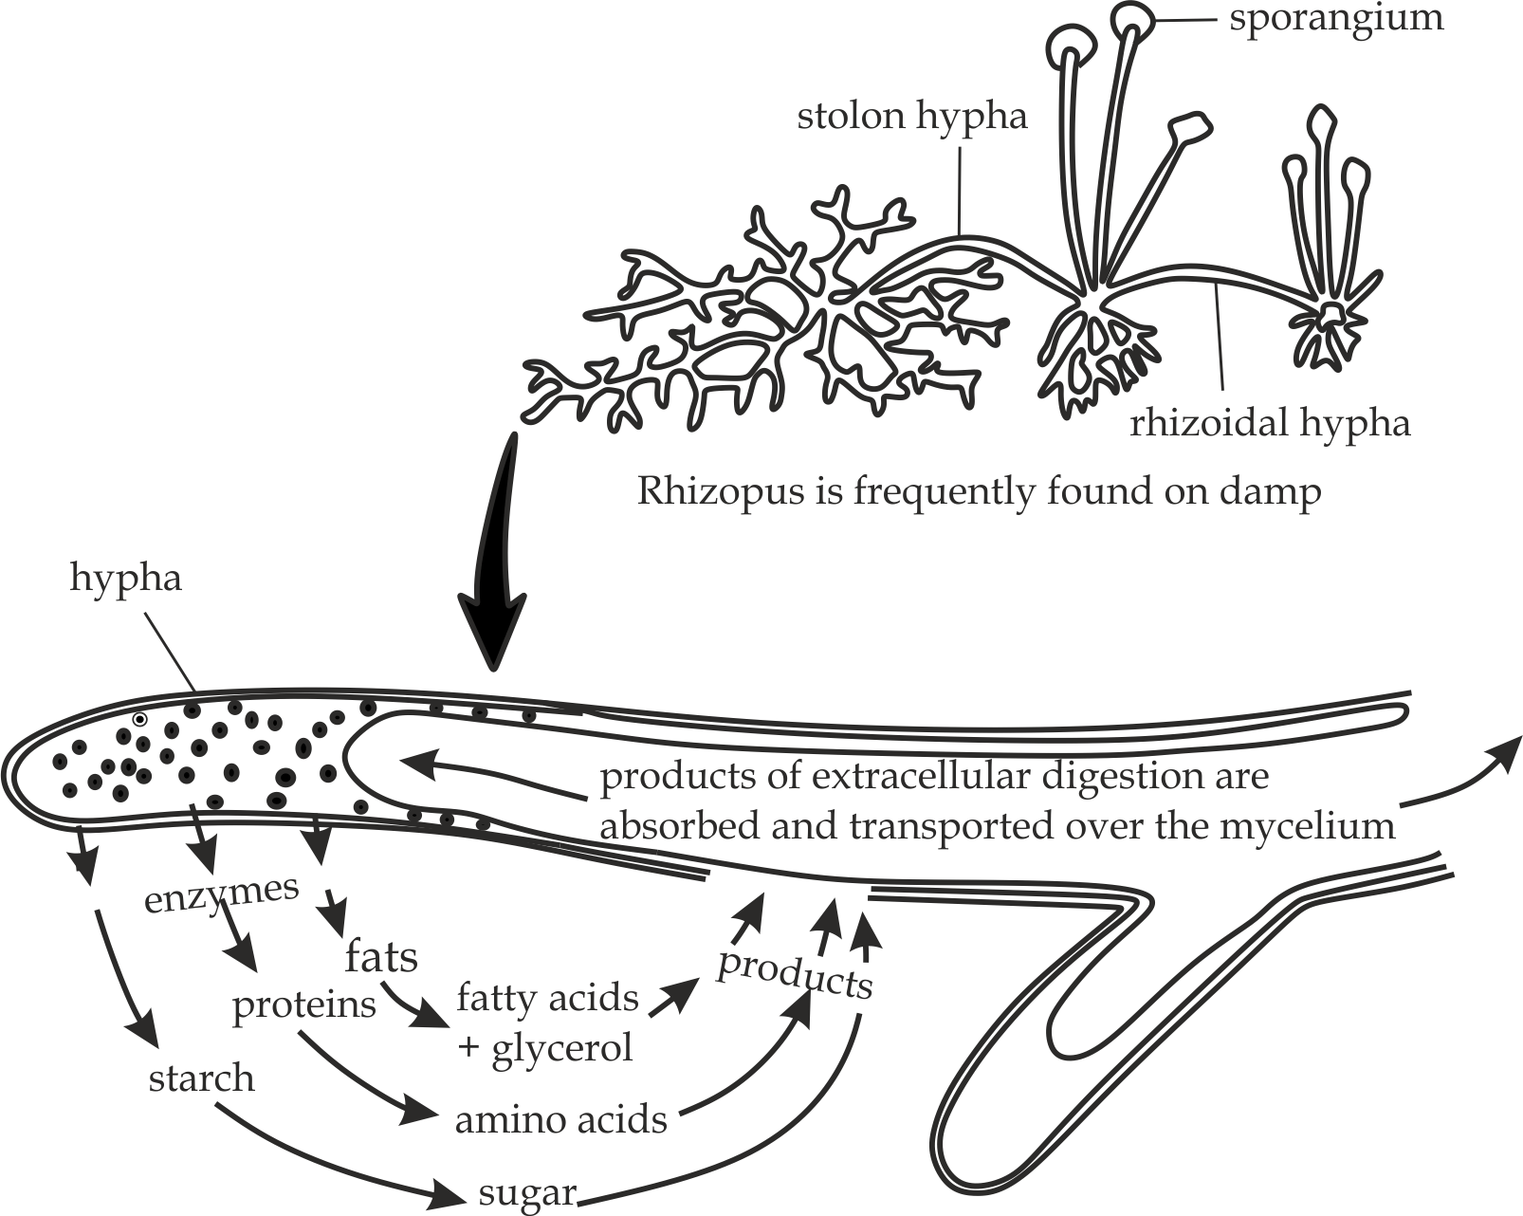

***Fig 5.1*** *Saprophytic nutrition of the fungi mucor and Rhizopus*

1. **Symbiotic nutrition (symbiosis)**

The term symbiosis literally means ″ living together”. In this type, organisms mainly of different species live in close association and depend on one another for food and shelter. There are three (3) common types of symbiotic relationship which are **mutualism**, **commensalism** and **parasitism.**

* **Mutualism**

This refers to the association between two living organisms of different species in which both benefits. Therefore, the association or relationship is beneficial to both partners. One of the best examples of mutualism is the relationship between Algaeand Fungiwhich is referred to as **lichen** shown in *Fig 5.2*. In this relationship usually algae synthesize food and supply some to the fungi while the fungi cover the algae and protect it from desiccation, also fungi roots absorb minerals and water from the soil and supply to the algae which normally photosynthesize its food. Mutualism form of symbiotic is also evident between leguminousplants and nitrogen fixing bacteria, where by the bacteria accommodated within the root nodules of these plants fix nitrogen from the air by converting it into nitrogen useful compounds such as nitrates. These nutrients are required by plants for their growth and development, while on the other hand, the bacteria benefit by getting shelter and synthesized nutrients from the plants. **Obligate mutualism** is a mutualism in which both benefit and absence of one species affect the other species; whereas **Facultative mutualism** is a one in which both benefit and absence one species does not affect the other.

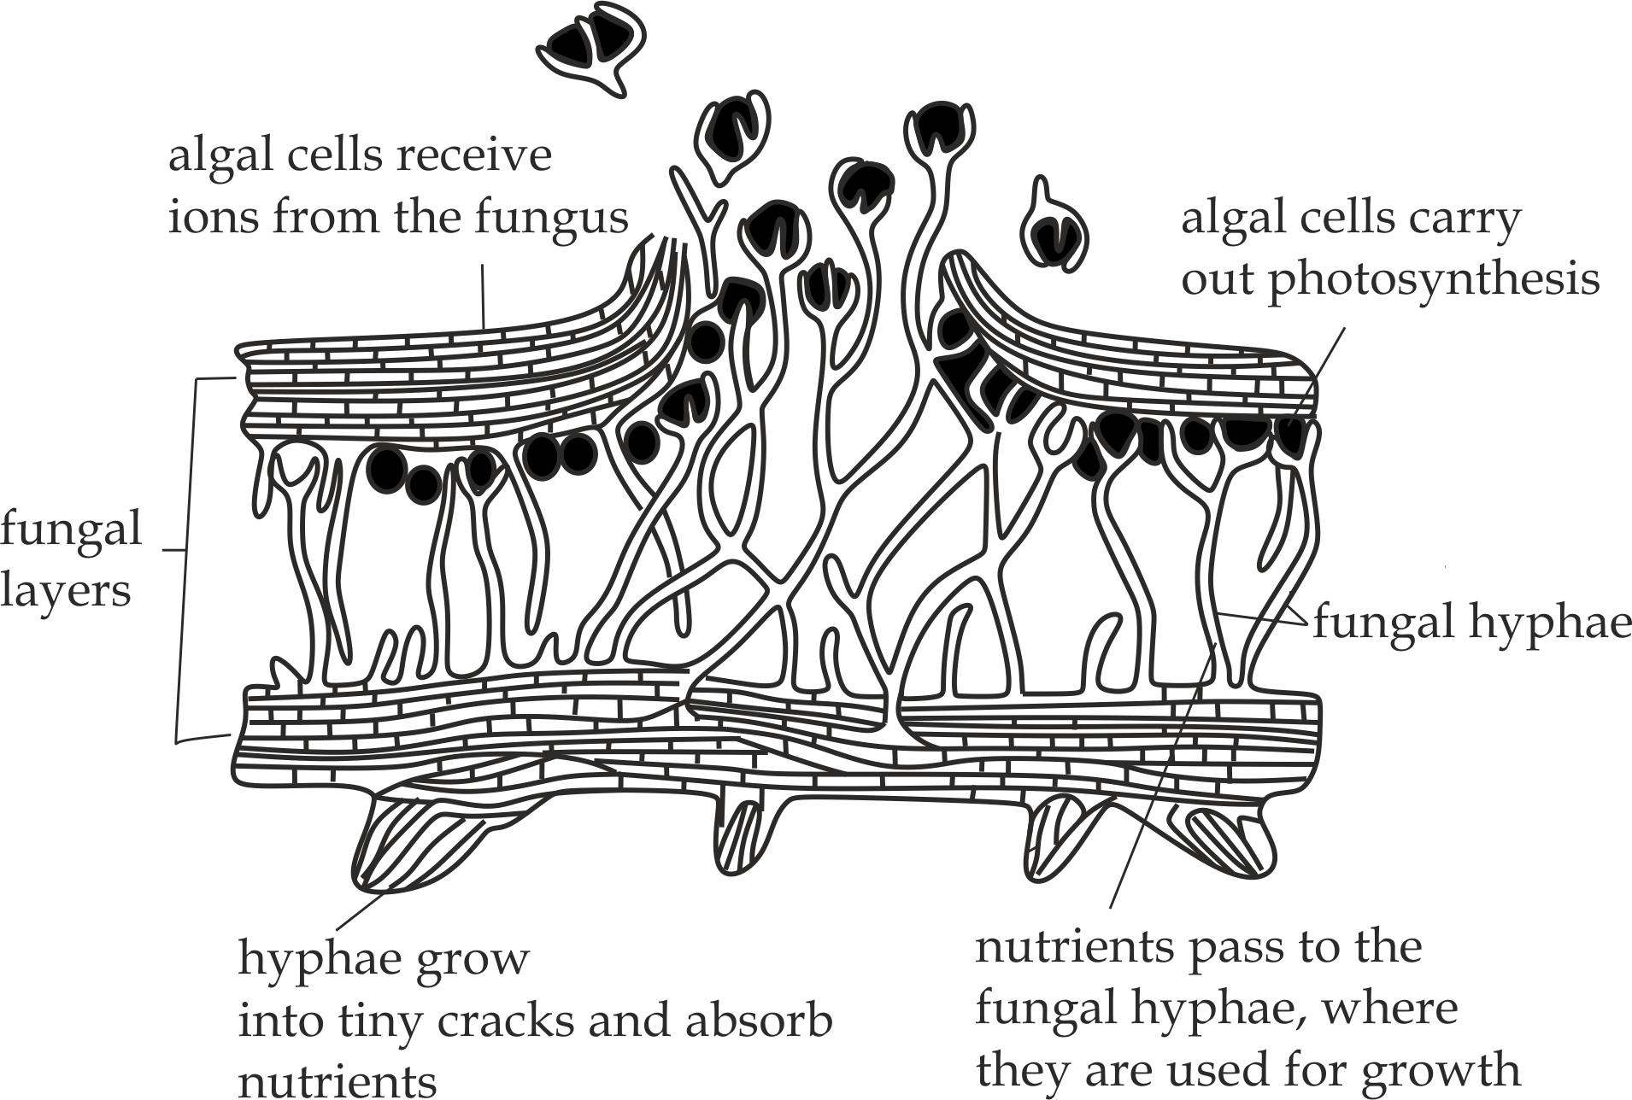

***Fig 5.2*** *Lichen as an example of mutualism*

* **Commensalism**

This refers to the association between two living organisms of different species in which one living organism (commensal) benefits and the other organism (host) neither benefits nor is harmed. One of the best examples is the relationship a type of hermit crab and colonial hydroid *Hydractinia echinata.* The hydroid obtains food particles from the crab and gain a way of moving about while the crab neither benefits nor is harmed. Another example of commensalism is evident between cattle egrets follows herds of cattle or buffalo and feed on insects disturbed by the animals, the cattle and buffalo are not harmed by the feeding activities of the cattle ergot. Therefore, in this association one member (The cattle egret) benefits while the other member (cattle or buffalo) neither benefits nor harmed.

* **Parasitism**

Parasitism refers to the close association between two organisms of different species whereby one organism called a parasite benefits by obtain its nutrients and shelter from another living organism called a host. Usually, the parasite may ultimately cause harm to the host, but in some cases it can exist without killing the host. Some parasites, for example tapeworm and liver fluke live inside the host body. These parasites are called **endoparasites.** On the other hand, some parasites such as ticks and bed bugs attach themselves on the surface of the body of their host and suck fluids from them, and these are called **ectoparasites.**

1. **Holozoic nutrition**

Holozoic nutrition is a type of nutrition in which organisms feed on complex food and digest it into soluble and absorbable molecules. This is a form of heterotrophic nutrition exhibited mainly by animals which have a specialized digestive tract, also known as alimentary canal. Holozoic organisms usually include animals such as **herbivores** which feed on vegetation, **carnivores** which feed on living animals; **Omnivores** which feed on both flesh and vegetation; and **decomposers** which feed on remains of dead animals and plants or their products such as faeces.

Holozoic nutrition involves **five (5)** main stages; ingestion, digestion, absorption, assimilation and egestion.

1. **Ingestion**

This process involves taking in solid or liquid food into the gut or alimentary canal of an organism through eating or drinking.

1. **Digestion**

This is a process of breaking down large and complex food into simple and more soluble molecules that can be easily be absorbed into the body. It involves both mechanical digestion which is brought about by the means of mechanical forces and chemical digestion which is brought about by the means of enzymes.

*(This part* *will be discussed in the nutrition in animals)*.

1. **Absorption**

This is the uptake of the digested soluble products across the lining of the gut into the blood stream and lymphatic system. *(This part also will be discussed in the nutrition in animals).*

1. **Assimilation**

This is the process of incorporating and using the absorbed food molecules into the body. The digested materials, which are absorbed into the blood, are carried by the blood stream to the body tissues for use in life processes such as growth, repairing body tissues and maintaining for good health. In addition, excess of such food materials may be stored for future use in liver, muscles and adipose tissues.

1. **Egestion**

Egestion is a process of eliminating the undigested food materials from the gut through the anus. This is the final stage in holozoic nutrition in mammals during which the undigested food materials or faeces are removed from the alimentary canal.

**Sample question – 02**

**Feza Boys – 2009**

1. What is holozoic nutrition? Explain the steps of holozoic nutrition.
2. Root nodules form a mutualistic relationship between a bacterium called rhizobium and leguminous plants. Explain the benefits of the relationship



**5.2: PLANT NUTRITION**

Nutrition in plants concentrates on the process of **photosynthesis,** which include the following main aspects:

* Introduction of photosynthesis
* Site of photosynthesis
* Mechanism of photosynthesis
* Light reaction
* Dark reaction
* Factors affecting photosynthesis

**5.2.1: INTRODUCTION OF PHOTOSYNTHESIS:**

**Photosynthesis:** refers to a physiological process in which organisms containing chlorophyll and carotenoids pigments manufacture their own food in the form of carbohydrates from inorganic raw materials such as carbondioxide and water using sunlight energy. Examples of photosynthetic organisms are green plants, euglena, green algae and some bacteria such as cyanobacteria. However, photosynthetic process which normally occurs in plants differs from that of bacteria (chemosynthesis) due to the following reasons: **Firstly;** plant photosynthesis uses energy from the sunlight while bacterial uses energy from the chemicals. **Secondly;** plant photosynthesis involves pigments such as chlorophyll while the bacterial involves bacteriochlorophyll. **Lastly;** unlike bacteria, plants release oxygen as a by-product.

**Significances of photosynthesis**

1. It is a primary source of energy for plants; because it is the process through which plant make their own food and animals depend on plants directly or indirectly for their food.
2. It releases oxygen to the atmosphere which is used in respiration to all organisms on the earth.
3. It reduces carbondioxide from the atmosphere, this may prevent global warming.
4. It converts sunlight form of energy into chemical energy.
5. It contributes to the carbon cycle in between the earth, the oceans, plants and animals.



**Sample question – 03**

**Form six special school – 2020**

1. State any four significances of photosynthesis.
2. Explain why the rate of photosynthesis usual decrease at high temperature?

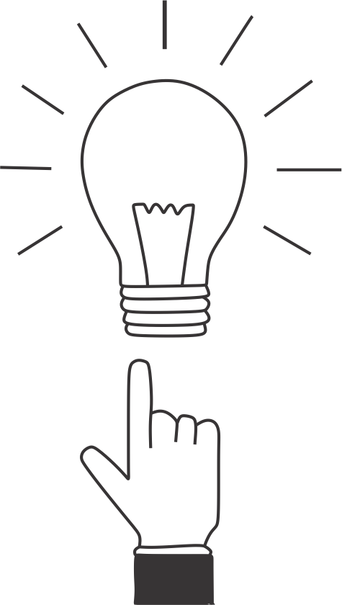

***Did you know?***

***It is estimated that 3.5 x 10 16 kg of carbon are fixed by plants per year.***

**Equations of photosynthesis**

In green plants, there are two equations of photosynthesis, the traditional equation and modern equation.

1. **Traditional equation:**

The tradition equation of photosynthesis is represented as:

Sunlight

6CO2 + 6H2O C6H12O6 + 6O2

Chlorophyll

Though the traditional equation is clearly balanced, it is considered as incorrect. The main reasons why it is not correct include:

1. It gives the hexose sugar as the end product of photosynthesis. However, the end product is a triose sugar compound (3c) called 3 – phosphoglyceraldehyde (3 – PGAL).
2. It shows that the source of oxygen is carbondioxide. This is not correct because in the isotopic experiment using O18 and O16 show that the source of oxygen is water and not carbondioxide.
3. It does not show that water is also given out as the end product, Thus more water enters the reaction so that some of it is evolved as by product as revelled in a more accurate modern equation of photosynthesis below.
4. **Modern equation:**

The modern equation of photosynthesis is represented as:

Sunlight

CO2 + 2H2O CH2O + O2 + H2O

Chlorophyll

**Sample question – 04**

**Mock Lake Zone – 2015**

Why is the following equation for photosynthesis said to be traditional?

6CO2 + 6H2O C6H12O6 + 6H2O

* Then, Write the modern (current) equation of photosynthesis.



**5.2.2: SITE OF PHOTOSYNTHESIS**

Photosynthesis takes place in the green parts of the plants leaves (mesophyll) and bundle sheath cells which usually have chloroplasts. A chloroplast is a double membrane bounded organelle. It contains cytoplasm – like stroma in which cell organelles are suspended. The cell organelles include circular DNA, free ribosomes, starch grains, lipid droplets, photosynthetic enzymes and stalks of flattened sacs or membranous called thylakoids which contain photosynthetic pigments called chlorophyll and other accessory pigments. Thylakoids are stalked together to form column – like structure called grana (singular – granum) as shown in *Fig 5.3*.

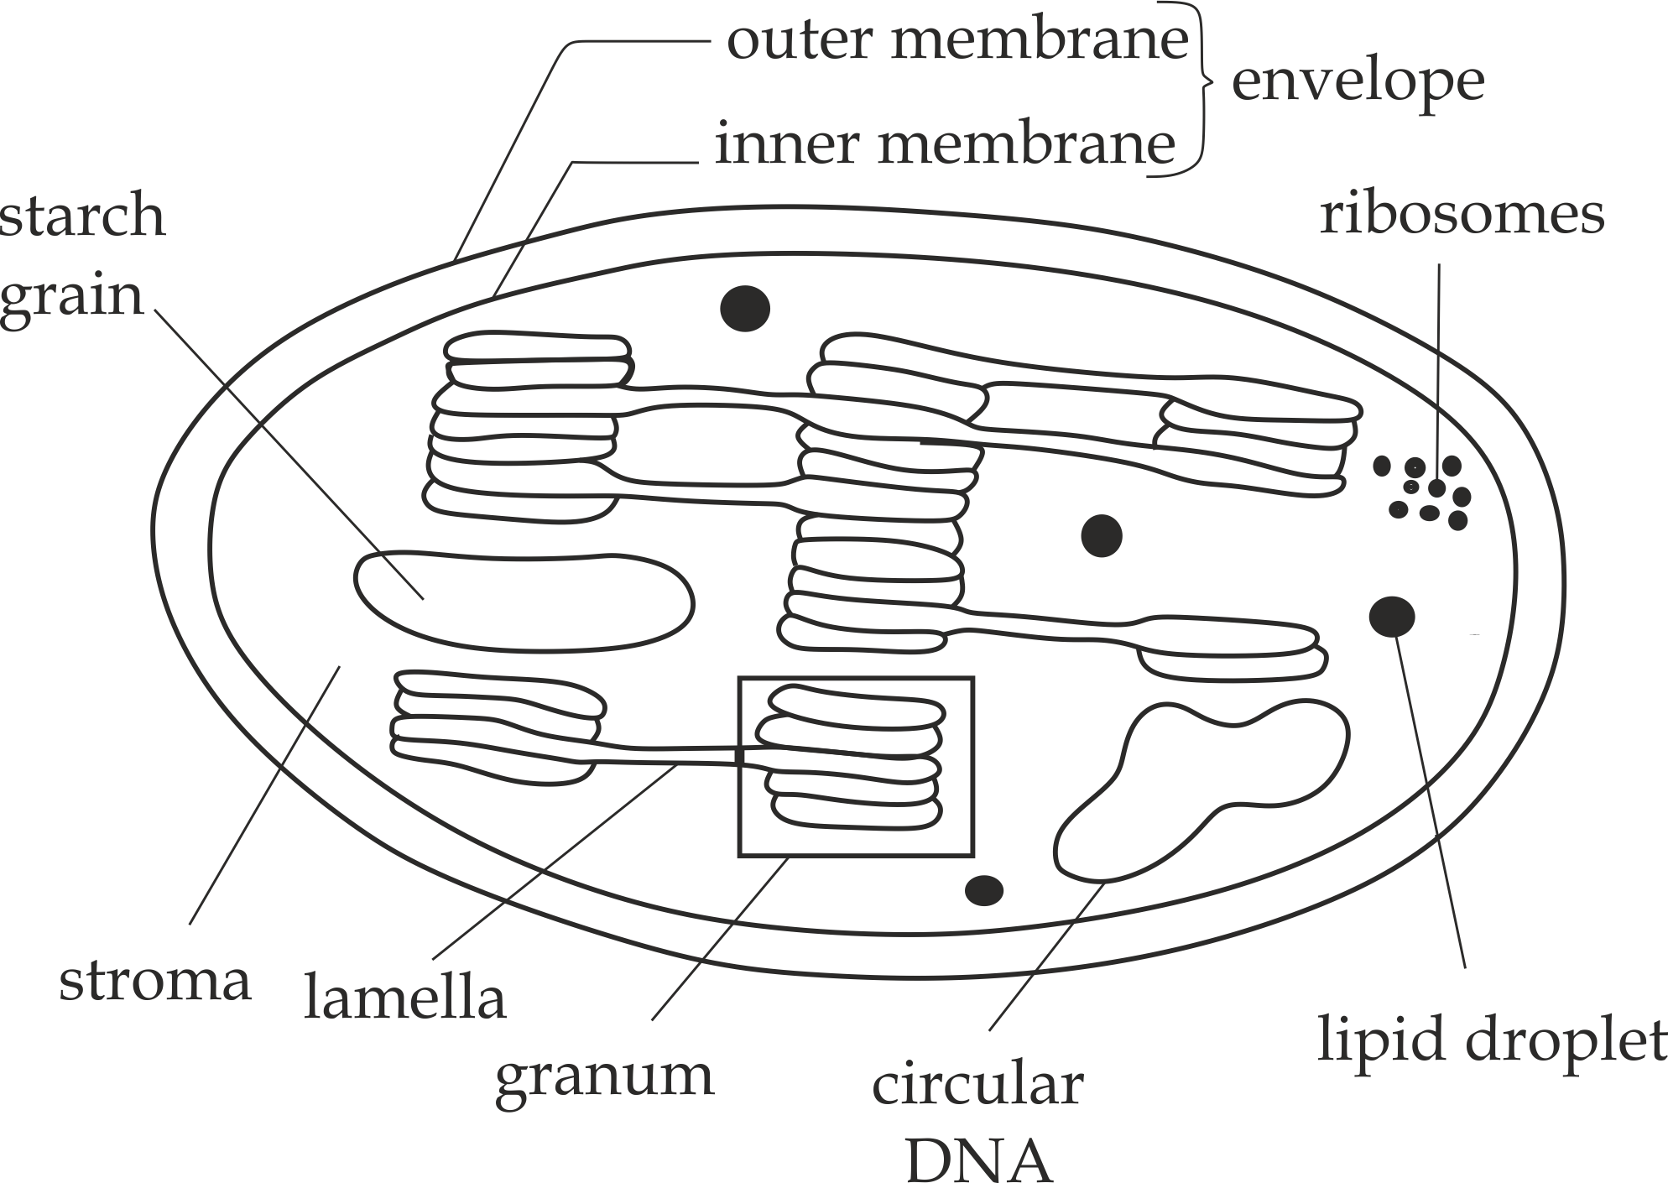

***Fig 5.3*** *Structure of chloroplast under electron microscope*

**Adaptations of the chloroplast**

The chloroplast is specialised to its function because:

1. Presence of **permiable membranes** which allow the movement of materials into and out of the chloroplast.
2. Presence of cytoplasmic like **stroma** which suspends cell organelles and also site for metabolic reaction such as dark reaction.
3. Presence of **circular DNA** for self replication and inheritance.
4. Presence of **ribosomes** for protein synthesis.
5. Presence of **grana** which hold photosystems and their chlorophyll in proper position for trapping of light.
6. Presence of **specific enzymes** enables chloroplast to carry out the photosynthetic reactions.
7. Presence of the large number of **chlorophyll** and **carotenoidspigments** which allow the maximum absorption of sunlight in photosynthesis.



**Sample question – 05**

**Dar Mock 2018**

The diagram below represents the structure of chloroplast.

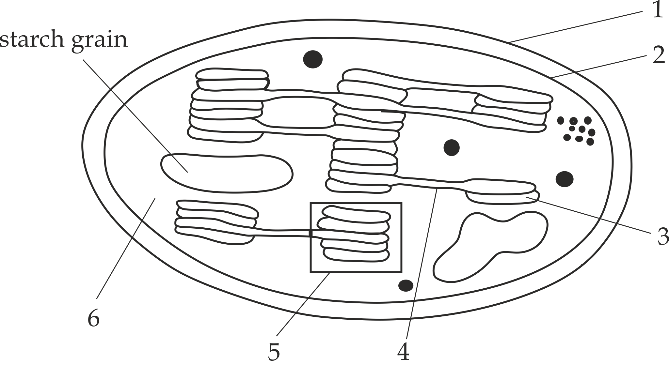

1. Name the parts labelled 1 – 6.
2. What reaction of photosynthesis occurs in structure 5 and 6?

**Photosynthetic pigments**

These are pigments molecules in the chloroplast which absorb sunlight energy and convert them to chemical energy for photosynthesis. In the chloroplast, the photosynthetic pigments are located on membranous system known as thylakoids.

**Types of photosynthetic pigments**

There are two (2) types of photosynthetic pigments based on their ability to convert light energy directly to chemical energy; which as follows: primary pigments and accessory pigments.

* **Primary pigments**

These are the photosynthetic pigments in the chloroplast which can directly convert light energy into chemical energy. The only primary pigment is **chlorophyll** **a** which acts as a reaction Centre. The principally function of reaction Centre is to transfer electrons to the highest energy level, for this reason is also referred to as **electron transfer system.**

**Note:**

**Chlorophyll a** absorb mainly in the red and blue - violet region of the light spectrum. They reflect green light, which is why plants look green.

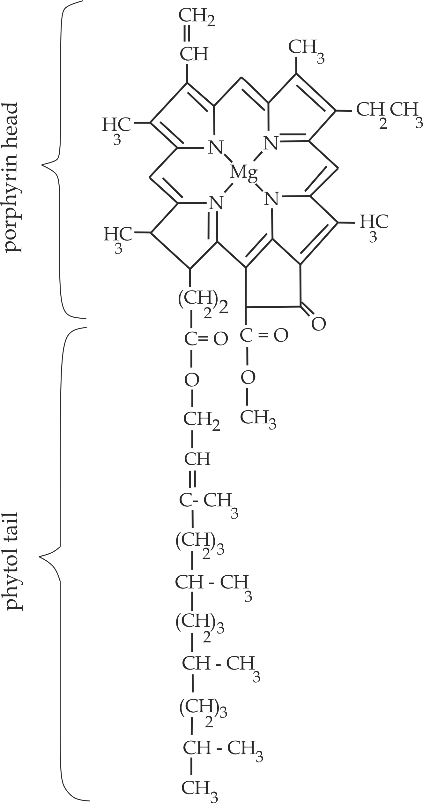

***Fig 5.4*** *Structure of chlorophyll a*

* **Accessory pigments**

These are pigments molecules which normally assist the primary pigment (chlorophyll a) to absorb light energy that is not capable of trapping. In other words, they can absorb photons with wide range of energies and pass the light energy to chlorophyll a.

Accessory pigments include in *fig 5.4* chlorophyll b and carotenoids which also act as antennae complex (light harvesting complex).Chlorophyll b is like chlorophyll a which also absorb red and blue – violet region of the light spectrum. The difference between chlorophyll a and b is that;

**″Chlorophyll a”** has terminal methyl group *(- CH3)* while **″chlorophyll b”** has an aldehyde group *(-CHO)* in the position, The difference changes the wavelengths of light absorbed and reflected by the chlorophyll b, making it appear yellow – green, whereas chlorophyll a appears bright green. Carotenoids are pigments that appear red, yellow or orange. They absorb light wavelengths strongly in the blue region of the spectrum.



***Did you know!***

***The red of ripe tomatoes and the orange of a carrot are produced by their carotenoids, i.e. β – carotene is the most abundant carotenoids that the animals ingest for synthesis of vitamin A.***

**Photosystem:**

Is the arrangement of the photosynthetic pigment molecules in the thylakoid in a particular ways that traps maximum light energy from the sun and convert it into chemical energy.

**Structure of photosystem:**

Photosystem has two (2) major components, the reaction Centre consist of primary pigment (chlorophyll a) and antennae complex consist of accessory pigments (chlorophyll b and carotenoids) shown in *fig 5.5*.

There are **two (2)** main forms of photosystems that are classified based on the type of reaction Centre; these are photosystem I and photosystem II. These two reaction centres differ not only in the structure of their chlorophylls but also in their functions, as we shall see.

* **Photosystem I (PSI)** is a type of photosystem which has a reaction centre activated by light of wavelength 700 nm; this reaction is referred to as P 700.
* **Photosystem II (PS II)** is a photosystem which has a reaction centre activated by light of wavelength 680 nm. This reaction centre is referred to as P680nm.

**Role of photosystem I (PSI) and photosystem II (PS II)**

* PS I and PS II produce ATP and NADPH2 which are used in the dark reaction of photosynthesis.

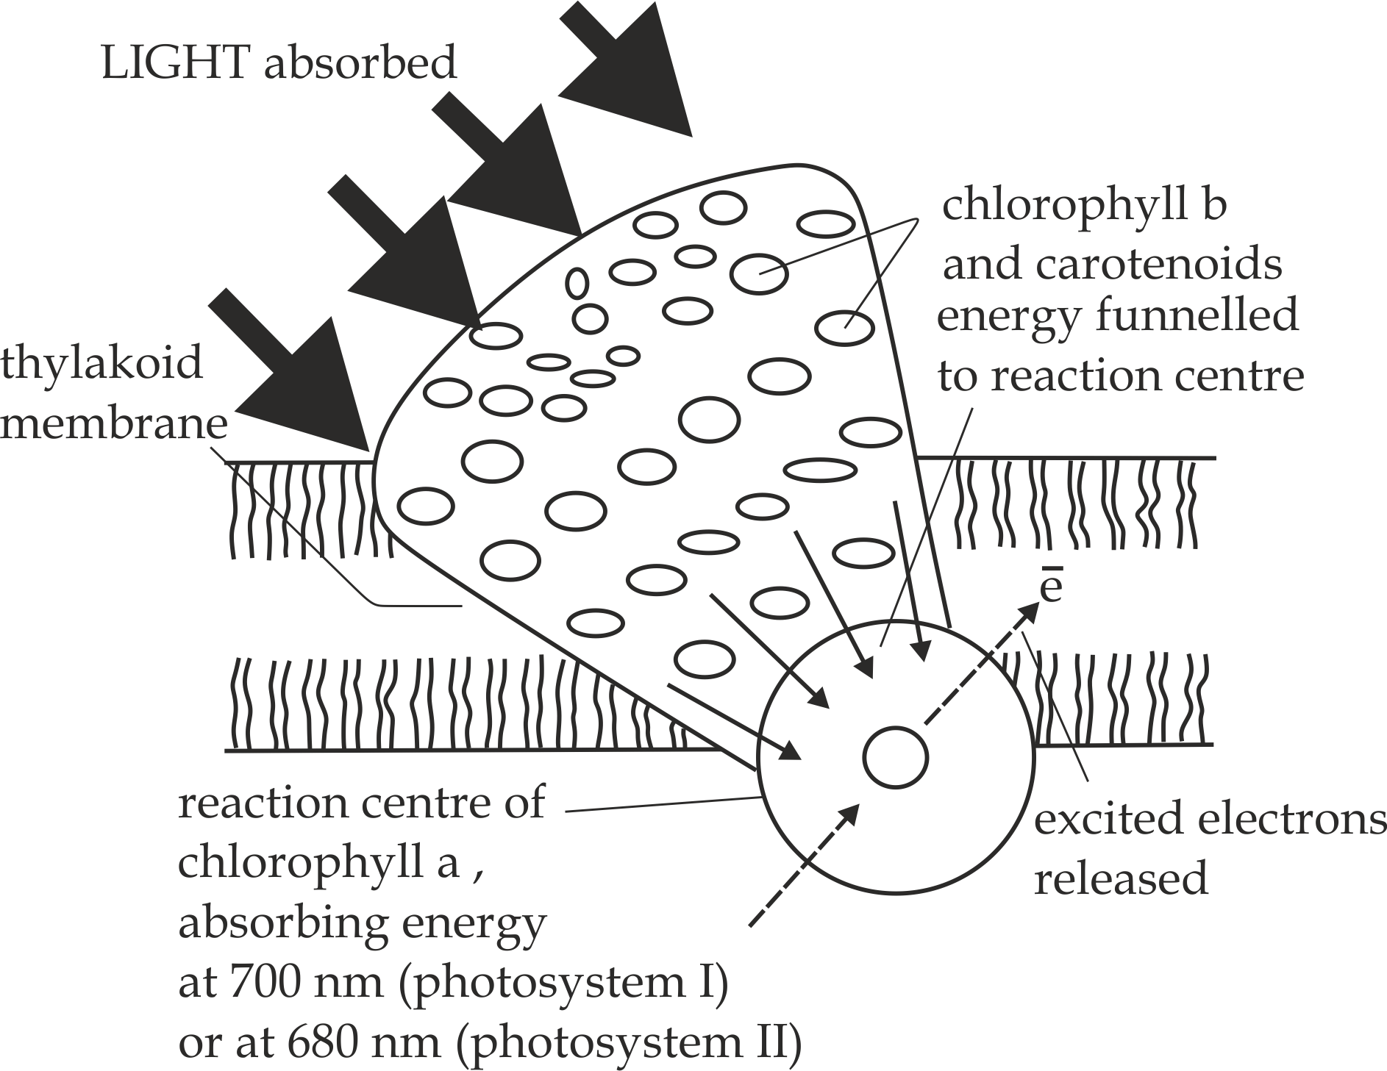

***Fig 5.5*** *Structure of photosystems*



**Sample question – 06**

**Mzumbe gauging- 2023**

1. Define the following terms:
2. Reaction centre
3. Antennae complex
4. Photosystem
5. i. Distinguish between photosystem I (PSI) and

PS II (photosystem II)

1. What is the role of photosystems (PS I and PS II).
2. State why photosystem I and II are referred to as *P680* and *P700* respectively?

**Absorption spectrum and action spectrum**

The **absorption spectrum** is a graph which shows the abilities of different pigments to absorb different wavelength of light as shown in *Fig 5.6*. Each photosynthetic pigment has its own specific absorption spectrum. Photosynthetic pigments tend to absorb light most readily at the blue or shorter wavelength. It is also interesting to note that none of the pigments absorb well in the green / yellow areas of the spectrum around 500 – 550 nm. This light, not being absorbed, is reflected which is why plants appear green.

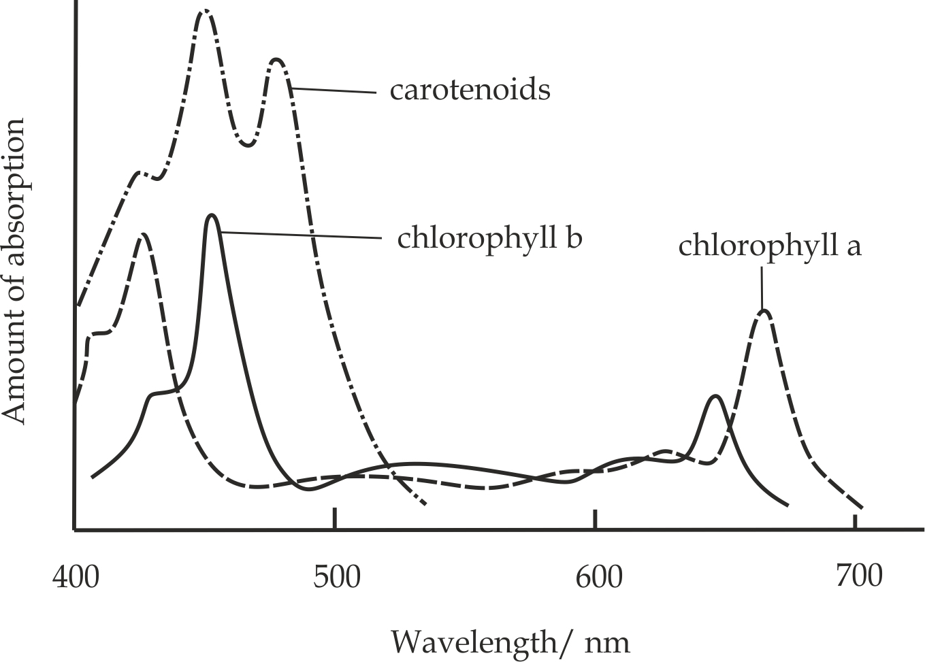

***Fig 5.6*** *The absorption spectrum*

**The action spectrum** is a graph of the rate of photosynthesis at different wavelengths of light as shown in *Fig 5.7*. This shows the effectiveness of the different wavelengths. The shorter the wavelength, the greater the energy it contains. **Carotenoid** is, therefore, not so efficient at using this light energy for photosynthesis. It, in fact, passes the energy on to **chlorophyll b** or **a.**

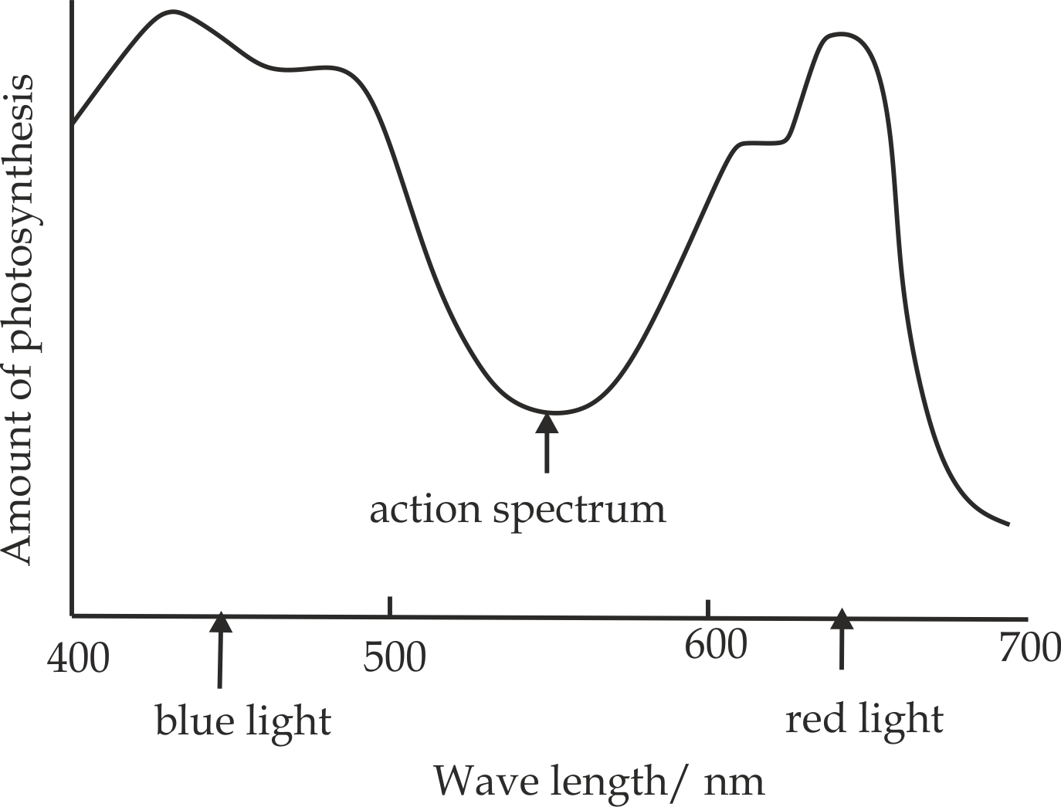

***Figure 5.7*** *Action spectrum*

**Sample question – 07**

**Msalato Midterm 1999**

The rate of photosynthesis at different wavelength of light can be measured and plotted as a graph. This is called an action spectrum and is shown on figure below.

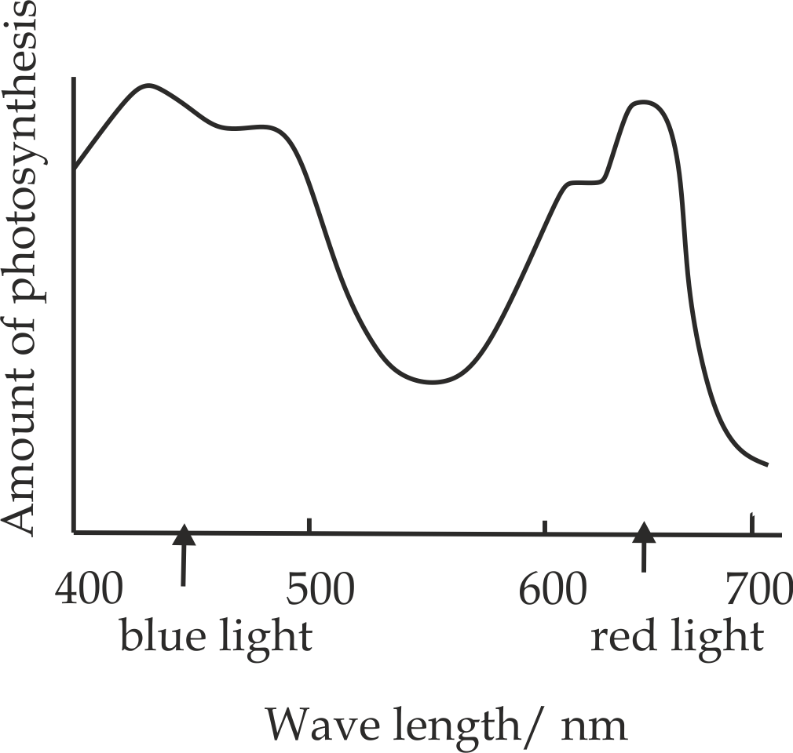

Describe and explain the effects of different wavelength of light on the rate of photosynthesis.



**5.2.3: MECHANISM OF PHOTOSYNTHESIS**

The photosynthesis can be viewed in two stages and these are light reaction (light dependent stage) and dark reaction (light independent stage).

1. **LIGHT REACTION**

**Light reaction** is a stage of photosynthesis which always proceeds in the presence of light energy. The site of light reaction is the grana (the stalk of circular thylakoids).

**Requirements for light reaction:**

1. **Sunlight energy**
2. It excites electrons from the chlorophyll in the photosystem to the high energy level acceptor.
3. It provides energy for splitting of water molecule during photolysis into oxygen, protons and electrons.
4. **Chlorophyll**
5. For trapping sunlight energy.
6. **Water**
7. It supplies electrons and protons.
8. It acts as a medium required for the chemical reaction
9. **NADP**+(Nicotinamide adenine dinucleotide)
10. In its reduced form it reduces PGA into PGAL.

PGA + NADPH2  PGAL + NADP+

1. It is a carrier of hydrogen atoms or electrons during light reaction.
2. **ADP+** (Adenosine diphosphate)
3. In its active form provides energy for reducing PGA into PGAL.
4. In its active form provides energy for regeneration of RUBP.



**Sample question – 08**

**Dar – Mock 2019**

What is the role of each of the following in photosynthesis?

1. Water
2. NADP+
3. Light

**Roles of light reaction**

The main role of light reaction includes the synthesis of ATP from ADP+ and Pi+ in **Photophosphorylation** and the splitting of water molecule by **photolysis** to give hydrogen protons. The hydrogen protons combine with a carrier molecule NADP to make reduced NADP.ATP and reduced NADP are used in the light – dependent stage in the stroma, by which sugar is synthesized from the carbondioxide.

**PHOTOPHOSPHORYLATION**

**Photophosphorylation** is a process of ATP synthesis by adding a phosphate group to ADP+ under the influence of sunlight energy. Photophosphorylation of ADP to ATP can be in a **non-cyclic** or **cyclic** way depending on the pattern of electron flow in the photosystem.

1. **Non- cyclic photophosphorylation**

This is a type of photophosphorylation whereby the electrons emitted from the **photosystems** do not go back to their original position.

**The mechanism of non-cyclic photophosphorylation:**

The mechanism of non –cyclic photophosphorylation involves both photosystem I and photosystem II, and both ATP and NADPH2 are formed by this non- cyclic pathway form of method as shown in *Fig5.8*.

* The photosystem I is activated by light of wavelength 700 nm and its chlorophyll release a pair of electrons to the highest energy level acceptor such as ferredoxin.
* The electrons are then transferred to NADP+ which does not only receive electrons but also a pair of hydrogen (H+) from photolysis of water which reduce it to NADPH2, as indicated by the following equation:

NADP+ + 2H+ + 2ē NADPH2

* While photosystem II is working the photosystem I also become activated by light of wavelength 680 nm, its chlorophyll release a pair of electrons to the highest energy level acceptor and through a series of carrier system such as the cytochromes proteins and finally to the photosystem I to replace the lost electrons, This may leave a gap of electrons in photosystem II.
* As the electrons from the photosystem II are passed through carriers energy is lost which is used to synthesize ATP from ADP+ and Pi under the influence of ATP synthase. Photolysis of water takes place, the electrons released fills the gap in the photosystem II.
* the end product of non – cyclic photophosphorylation are ATP molecules and reduced NADP which are the raw materials for dark reaction which produce carbohydrates while the oxygen gas from photolysis of water is released into the air as a by-product.

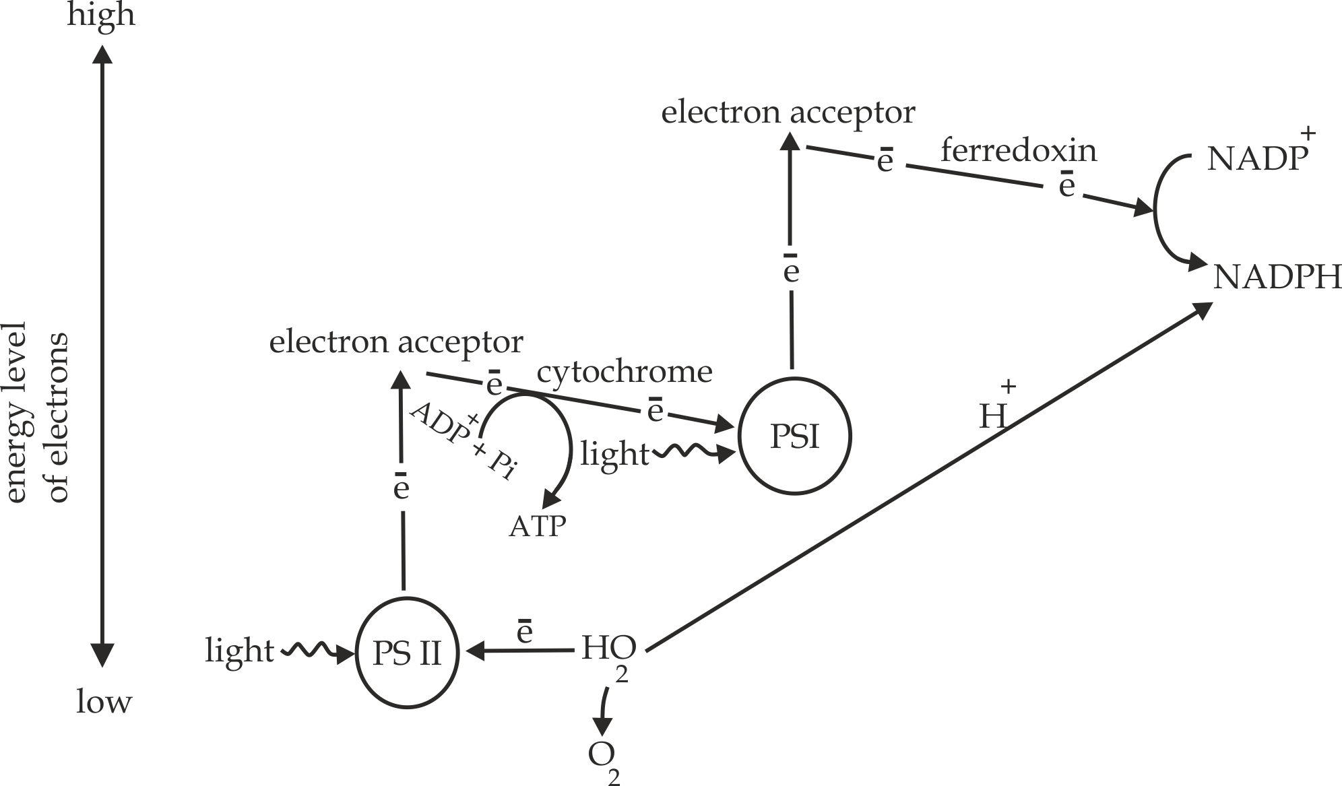

***Fig 5.8*** *Non cyclic photophosphorylation*

**Fates of electrons in non-cyclic photophosphorylation**

1. Electrons lost from the photosystem I together with hydrogen protons are used to reduce NADP+ into NADPH2.
2. Electrons lost from the photosystem II are used to replace the electrons in photosystem I.
3. Electrons from the photolysis of water are used to replace electrons lost in photosystem II.

**Sample question – 09**

**Style1: Mock Eastern Zone – 2020**

1. Define the photophosphorylation.
2. Describe how energy in the form of ATP and NADH2 is formed during the process of non-cyclic photophosphorylation.



**Style 2: Pre – Mock Dar 2018**

1. Study the **figure 1** below and answer the questions which follow:

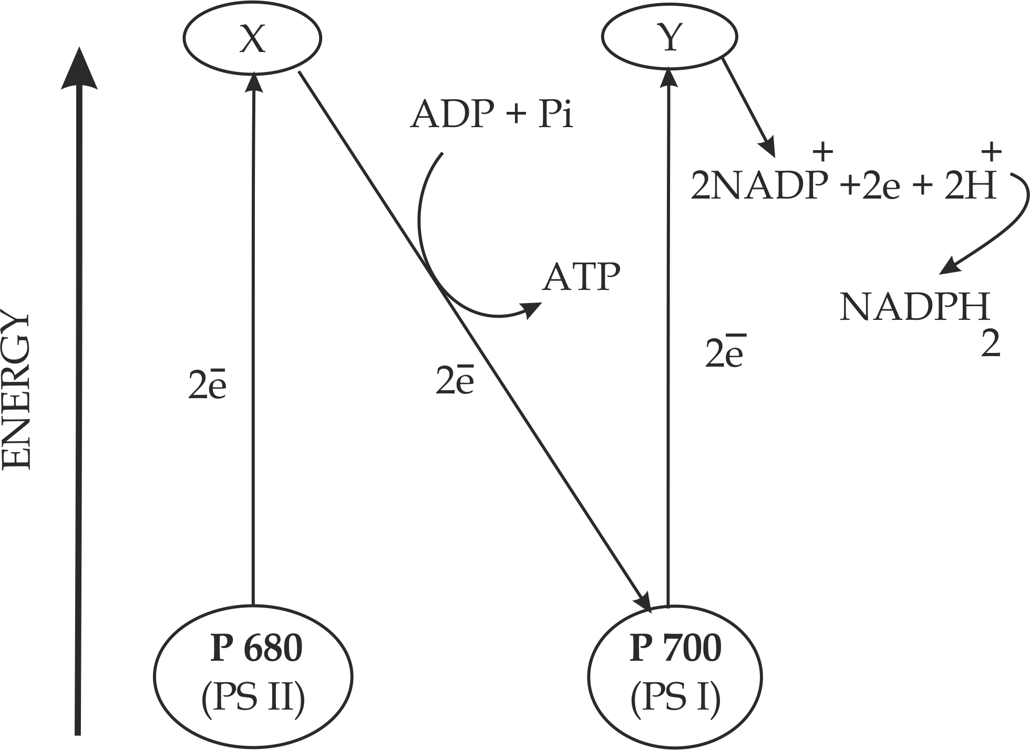

**Figure 1**

1. Identify the figure 1 above.
2. Outline two roles of ATP and NADPH2.
3. State why photosystem I and II are referred to as P 700 and P 680 respectively?
4. What will happen if water (H20) is absent? Give reasons
5. What are the fate of electrons in non-cyclic process photophosphorylation?



* **Cyclic photophosphorylation**

This is a type of photophosphorylation whereby electrons emitted from the photosystem go back to its ground state position. Cyclic phosphorylation involves only photosystem I and only ATP is formed; NADPH is not formed by this method. Cyclic pathway alone would not have been enough to sustain the evolution of photosynthetic land plants.

**Mechanism of cyclic photophosphorylation**

* The photosystem I is activated by light of wavelength 700nm and its chlorophyll release a pair of electrons to the highest energy level acceptor (ferredoxin) then electrons are passed through a series of carrier’s molecules including cytochrome back to their original ground position in the photosystem.
* As electrons travel back, they release energy which is used to form ATP from ADP+ and Pi under the presence of ATP synthase. In this cycle, only ATP molecule is produced as shown in *Figure 5.9*.
* The amount of ATP molecule required in the cyclic pathway is much higher than that produced in the non-cyclic photophosphorylation. This makes the cyclic photophosphorylation important to balance the ATP molecule deficit without increasing NADPH. However, the energy available by the cyclic process alone cannot support photosynthesis.

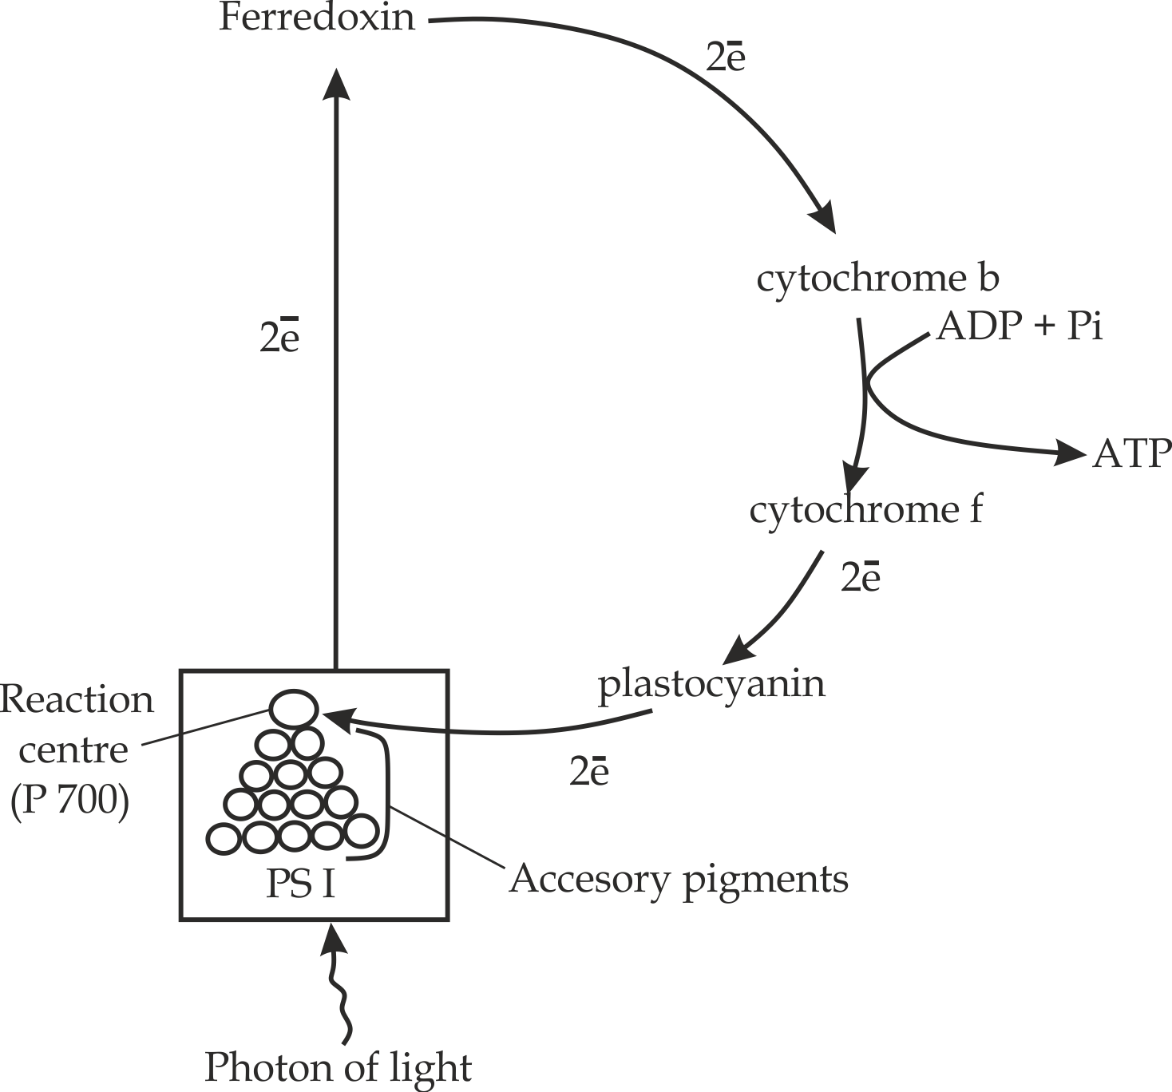

***Fig 5.9*** *Cyclic photophosphorylation*

**Sample question – 10**

**Necta 1999**

1. Compare between the photosynthetic and oxidative phosphorylation.
2. Describe how energy in the form of ATP is formed during cyclic phosphorylation.



Differences between cyclic and non-cyclic

|  |  |
| --- | --- |
| **Cyclic photophosphorylation** | **Non cyclic photophosphorylation** |
| The pathway of electrons is cyclic | The pathway of electrons is non-cyclic |
| It involves only one type of photosystem (P700) | It involves two photosystems (P700 and P680) |
| Photolysis of water does not occur | Photolysis of water occurs |
| The end product is ATP only | The end products are NADPH , ATP and oxygen |
| The final electron acceptor is photosystem I | The final electron acceptor is NADP+ |
| The first source of electrons is photosystem I | The first source of electrons is water |

**Sample question – 11**

**Necta 1998**

1. Define photophosphorylation.
2. List three (3) differences between cyclic and non-cyclic photophosphorylation.



1. **DARK REACTION**

**Dark reaction** is a stage whose reactions proceed in the absence of light. It is also known as light independent stage and it occurs in the stroma of the chloroplast and involves many chemical reactions, each catalyzed by a different enzyme. The light independent state requires the products of the light dependent state (ATP and NADPH2), but does not itself require light; this is why it is referred to as a ″ dark” reaction. Of course the light dependent stage and the light independent stage occur simultaneously in chloroplast within the leaf during daylight, each depends upon the other.

**Aim of light independent stage**

In the light independent stage, (CO2) carbondioxide is usually converted into carbohydrate.

**The requirements of dark reaction:**

1. ATP molecules
2. Reduced NADP (NADPH)
3. Carbondioxide
4. Water
5. Ribulose Bisphosphate (RUBP) for Calvin cycle (C3 pathway)
6. Phosphoenolpyruvate (PEP) for hatch – slack pathway (C4 pathway) and CAM pathway.

**The mechanism of Dark reaction**

The mechanism of dark reaction is normally divided into three (3) main pathways depending on the produced first product:

* C3 pathway (Calvin cycle)
* C4 pathway (Hatch – slack pathway)
* CAM (Crassulacean acid metabolism)

1. **C3 pathway:**

This is a pathway in which the first end product of dark reaction is 3 carbon sugars known as **glycerate 3- phosphate (GP**).Because the 3 – carbon molecule glycerate phosphate (GP) is the first product of carbondioxide (CO2) fixation in the Calvin cycle, the pathway just described is known as the C3 pathway and plants which have it are called C3 plants. The C3 pathway is typical of plants in temperate areas. C3 plants are common and widely distributed 85% of known plant species are C3 plants, they include Cereals (wheat, barley, and rice), potatoes, soya beans and most trees.

This pathway is also known as ″**Calvin – Benson cycle”** named after the America scientists who first trace the pathway Dr Melvin Calvin and Andrew Benson. Calvin *(Fig 5.10)* acquired his interest in photosynthesis whilst a post graduate student in the 1930s. On return to the USA he worked almost exclusively on this aspect of plant metabolism. He was awarded a **Nobel Prize in 1961**.

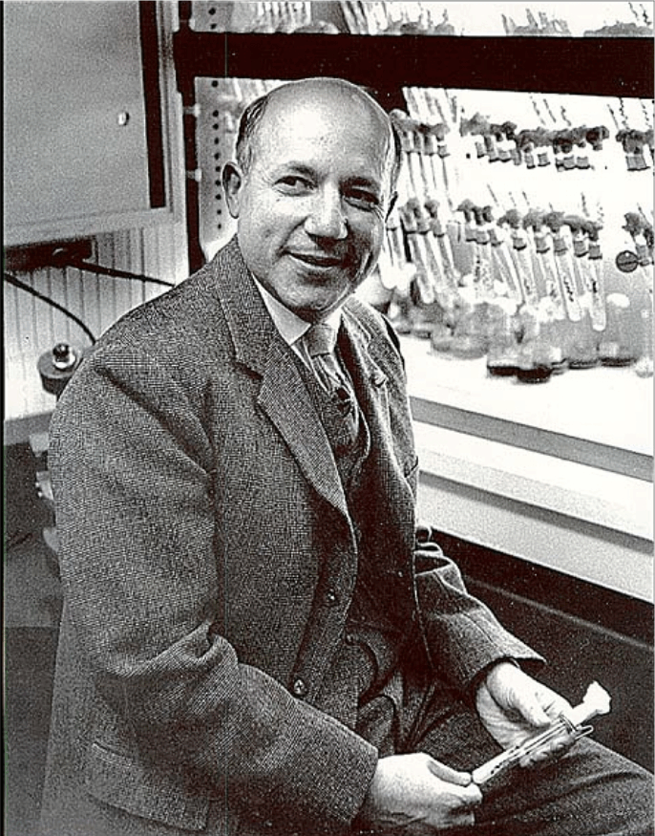

***Fig 5.10****: Dr Melvin Calvin* who discovered the dark stage of photosynthesis

**Mechanism of dark reaction according to C3 pathway (Calvin cycle)**

The mechanism of dark reaction due to C3 pathway is divided into three (3) main phases, which include; carbondioxide fixation, reduction phase and regeneration of RUBP as shown in *Figure 5.11*.

1. **Carbondioxide fixation**

In this first step, the carbondioxide (CO2) combines with a 5 – carbon organic compound called **Ribulose Bisphosphate** (abbreviated to RuBP) under the presence of RuBP carboxylase (RuBisco) to form unstable 6 – carbon compound which splits immediately into two molecules of a 3 – carbon compound, (glycerate 3-phoshate- GP) *.*RuBP is therefore called the carbondioxide acceptor due to its ability to accept or combine with (CO2) carbondioxide.

RUBP carboxylase

RuBP + CO2 2 PGA

1. **Reduction of glycerate 3- phosphate**

Each glycerate 3- phosphate (PGA) is phosphorylated by ATP and reduced by NADPH to form triose phosphate, PGAL.This reaction that uses NADPH and ATP from the light independent reaction and it signifies the reduction of carbondioxide to a carbohydrate (CH2O).

PGA + NADPH2 + ATP PGAL + NADP+2 + ADP + Pi

1. **Regeneration of RuBP**

Most of PGAL is used to regenerate RuBP for further fixation of carbondioxide from the atmosphere. This process involves a complex series of rearrangement of the carbon atoms between sugar phosphates to generate 5 – carbon sugar phosphate from 3 – carbon sugar under the presence of ATP from light dependent stage.

PGAL + ATP RUBP + ADP+ + Pi

**What are the fates of PGAL?**

1. Majority of the PGAL are used to regenerate RuBP for further fixation of carbondioxide gas.
2. Some of the PGAL molecules are condensed into hexose sugar and also disaccharides such as sucrose and polysaccharides such as starch.
3. Some of the PGAL are enzymatically converted into fatty acid molecules and glycerol hence lipids.
4. Some of the PGAL molecules in addition to nitrogen is converted into amino acids hence proteins

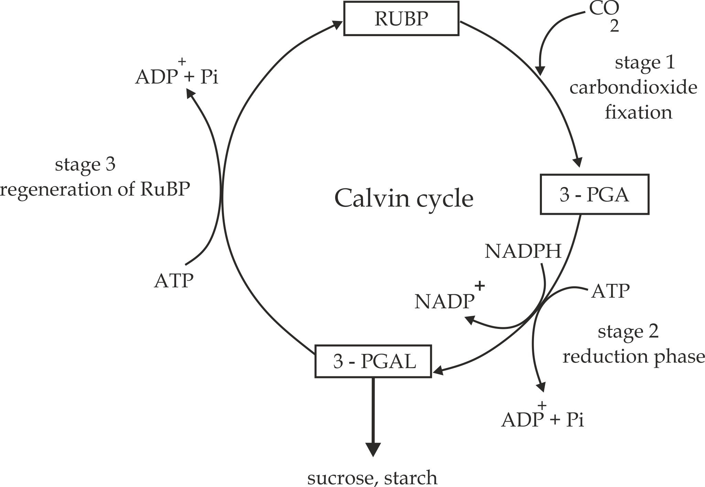

***Figure 5.11*** *The main steps in Calvin cycle*

**Sample question – 12**

**Kilakala Midterm 2019**

1. Naming C3 cycle as dark reaction sometimes misleading, substantiate.
2. Explain events which take place during dark reaction.
3. What is the fate of PGAL? Illustrate your answer by means of a simplified diagram.
4. Write a balanced equation of photosynthesis and from the equation, state which factors and conditions are likely to affect the rate of photosynthesis.

**Hints (a)**

Naming C3 cycle as dark reaction is sometimes misleading because the reaction does not occur in the darkness.



**Problem faced by C3 plants**

During hot and dry conditions, C3 plants close their stomata to prevent water loss, which also prevent gaseous exchange taking place, and so levels of oxygen build up and carbondioxide concentration is depleted, as a result of raised oxygen levels, RuBisco enzyme combine with oxygen instead of carbondioxide, a process called **photorespiration**.

**Why C3 plants undergo photorespiration?**

The following features of RuBisco enzymes in C3 plants fail to raise the carbondioxide concentration in hot and dry condition; and therefore enhance photorespiration:

1. RuBisco enzyme has very low affinity to carbondioxide, as a result; insufficient carbondioxide can be fixed to supply the plant for a short time by having stomata open for a very short time.
2. RuBisco enzyme is competitively inhibited by oxygen on its active site.



**Remember:**

**Photorespiration** is a process whereby RuBisco enzyme combines with oxygen to form one molecule of 3- PGA (three carbons) and 2- phosphoglycolate (2 – carbon molecules).

RuBisco

RUBP (3 – PGA) + 2(Phosphoglycolate)

(5c) (3c) (2c)



***Did you know!***

***“Overall photorespiration is a wasteful process, and may reduce the potential yield from photosynthesis in C3 plants by up to 50%“***

Some plants trap CO2 in a way which overcomes the limitations of the C3 pathway. In this new pathway, carbondioxide is used to make a four – carbon compound, oxaloacetate, so it is called **C4 pathway**. Plants using the C4 pathway include maize and many grasses. The main stages of the C4 pathway are discussed in the next page in which the four – carbon compound are formed.

1. **C4 – pathway**

This is a pathway in which the first end product of dark reaction is 4 – carbon molecule known asoxaloacetate (OAA).This pathway is also known as **Hatch –** **slack pathway**, named following the Australian scientist who worked the pathway **Hal Hatch** and **Roger Slack** in **1966.** C4 plants are mainly tropical and subtropical in origin; examples include maize, sugar cane, tropical grasses and sorghum. The C4 pathway is divided into two (2) phases; Part I; takes place in mesophyll and Part II; takes place in the bundle sheath cell as shown in *Fig 5.12*.

1. **Part I; in mesophyll cell**

Phosphoenol pyruvate (PEP) reacts with carbondioxide (CO2) to produce a four – carbon molecule called oxaloacetate (4c) under the presence of PEP carboxylase enzyme. The PEP carboxylase has higher carbondioxide binding affinity compared to RuBP carboxylase which is used in carboxylation in C3 plants.

PEP carboxylase

PEP +CO2 Oxaloacetate

Oxaloacetate formed is further reduced by NADPH2into malate, which is shunted to the bundle sheath cell.

Oxaloacetate + NADPH2 malate + NADP+

1. **Part II; in bundle sheath cell**

Malate undergoes decarboxylation and dehydrogenation to produce pyruvate and carbondioxide.

Malate + NADPH2  pyruvate + NADP+

The released carbondioxide from the malate combine with RUBP to produce 3 – PGA which is then converted into sugar as per Calvin cycle. Pyruvate formed is transported back to the mesophyll cell where it is then being phosphorylated by ATP to regenerate PEP for further fixation of carbondioxide.

The **malate shunt** has effect on two (2) major pump in C4 pathway:

* **CO2 – pump:**

The malate (4C) pump increase carbondioxide concentration in the bundle sheath cells thus increasing efficient to which RuBisco enzyme functioning.

* **Hydrogen pump:**

The malate (4C) carriers’ hydrogen atoms from NADPH2 in the mesophyll cell to the bundle sheath cell where PEP is regenerated.

**Advantages of the malate shunt in CO2 and hydrogen pump:**

The advantage is that NADPH2 is generated by the efficient light reaction in the mesophyll chloroplast and can be used as reducing power in the Calvin cycle of bundle sheath chloroplast whose own synthesis of NADPH2 is limited.

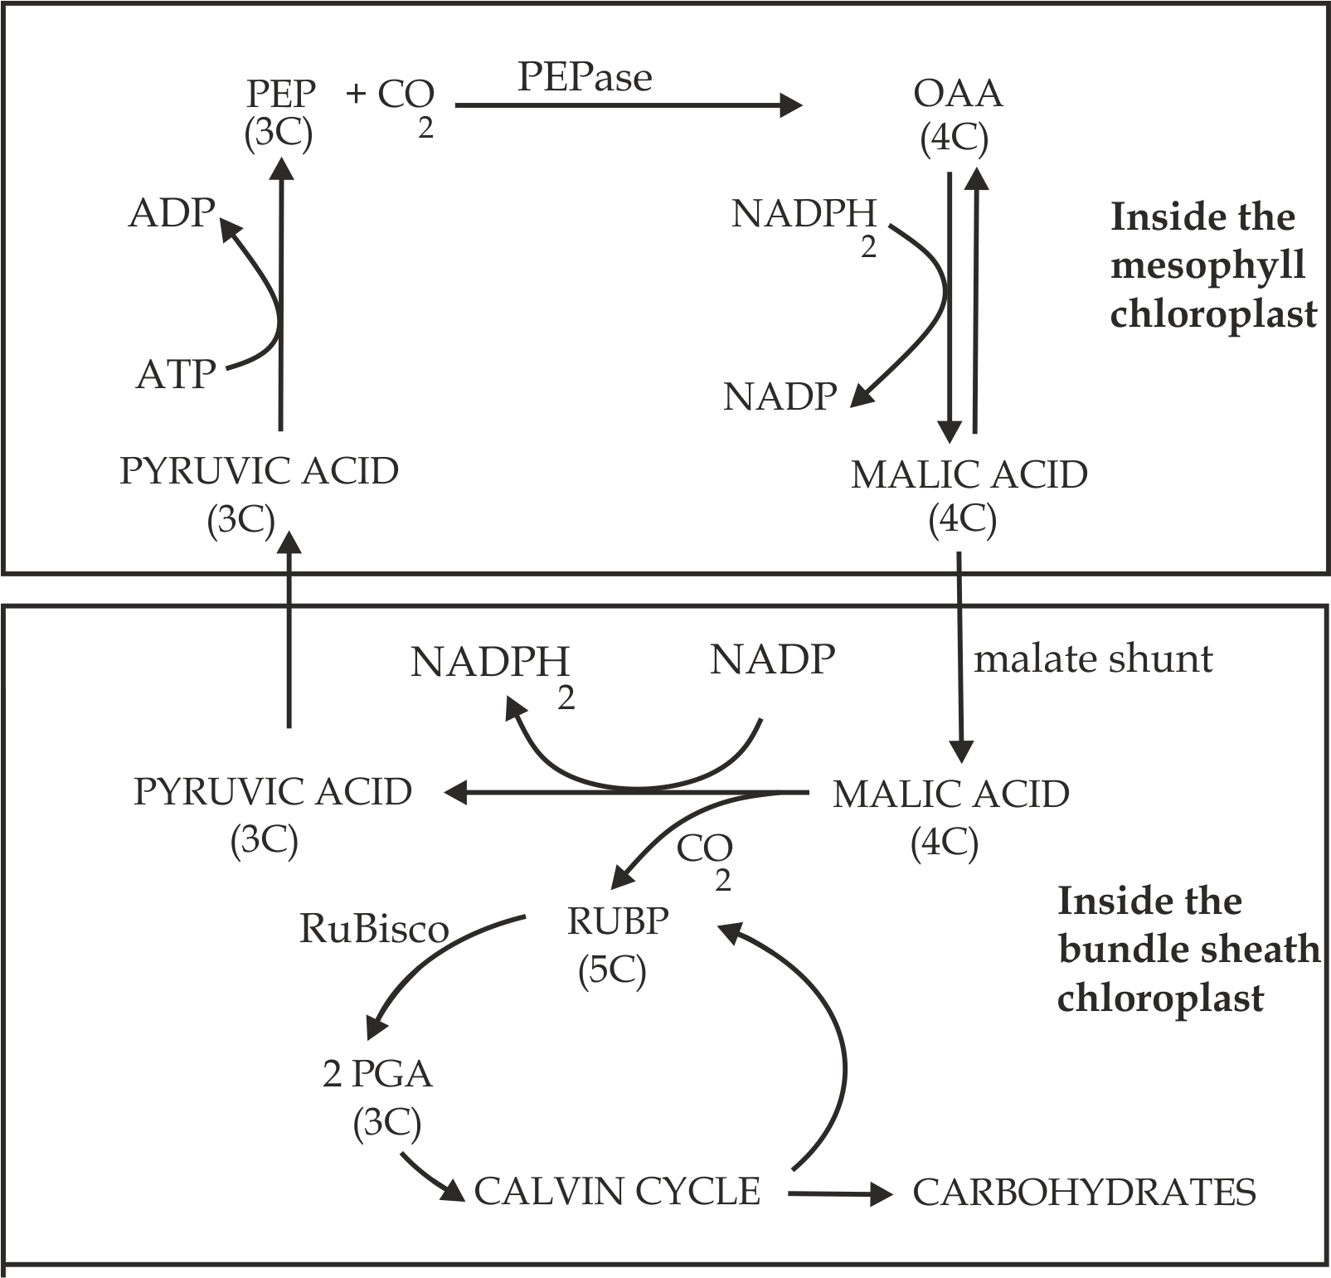

***Fig 5.12*** *The main steps in hatch – slack pathway*



**Sample question – 13**

**Tahossa Pre – national 2022**

1. Explain Hatch – Slack pathway in C4 plants.
2. Malate shunt has effect on carbondioxide and hydrogen pump;

Argue for this statement, what advantage of the statement above.

***Table 5.0* Differences between bundle sheath and mesophyll chloroplast**

|  |  |
| --- | --- |
| **Mesophyll chloroplast** | **Bundle sheath chloroplast** |
| Large grana, light dependent reaction is favored | No grana, light dependent reaction is not favored |
| Presence of PEPase enzyme as carbondioxide acceptor | Presence of RuBisco enzyme as carbondioxide acceptor |
| Little starch | Abundant starch |

**Remember!**

**Bundle sheath chloroplast** lack grana to decrease the chance of photorespiration, this is because grana favours much light dependent reaction which gives oxygen as a waste product, as the result RuBisco in the bundle sheath is competitively inhibited by oxygen



***Table 5.1* Differences between C3 and C4 plants:**

|  |  |  |
| --- | --- | --- |
| **Criteria** | **C3 plants** | **C4 plants** |
| **Carbondioxide acceptor** | The carbondioxide acceptor is a five carbon compound called RUBP | The first carbondioxide acceptor is 4 – carbon compound (PEP) and the second acceptor is five carbon compound RUBP |
| **Carbondioxide fixation** | In mesophyll cells only | In both; mesophyll cells and bundle sheath cells |
| **Carbondioxide fixing enzymes** | Have RUBP carboxylase to fix carbondioxide | Have RUBP carboxylase and PEP carboxylase to fix carbondioxide |
| **First product of photosynthesis** | 3 – carbon compound called phosphoglycerate | 4 – carbon compound called oxaloacetate |
| **Leaf anatomy** | They have only one type of chloroplast | They have two types of cells, each with its own type chloroplast (kranzy anatomy) |
| **Photorespiration** | It may occur in a limited supply of carbondioxide | It does not occur |
| **Efficient** | It is less efficient in hot and dry condition | It is more efficient in hot and dry condition |



**Sample question – 14**

**Jecas 2019**

1. Why bundle sheath chloroplast in C4 plants lack grana?
2. Give the differences between C3 and C4 plants based on the following criteria:
3. First product of photosynthesis
4. Leaf anatomy
5. Carbondioxide acceptor
6. Carbondioxide fixing enzyme
7. Carbondioxide fixation

**Advantages of C4 plants over C3 plants**

C4 plants are more efficiently than C3 plants because: they have the following mechanism which maintains the concentration of carbondioxide and hence photosynthesize by supressing photorespiration;

1. PEP carboxylase has a high affinity to carbondioxide, as the result; sufficient carbondioxide can be fixed to supply the plant for a day by having stomata open for a very short time. Thus; PEP carboxylase help the C4 plants to photosynthesize even if the stomata are closed.
2. PEP carboxylase is not competitively inhibited by oxygen; thus can prevent the photorespiration.
3. The ability to store carbondioxide the form of C4 acids such as malic acid for future use.



**Sample question – 15**

**Style 1: Dar Mock 2021**

* Why the rate of photosynthesis in C4 plants is not enhanced by higher atmospheric carbondioxide concentration yet in C3 plant it is.

**Style 2: Tahossa Ilala 2020**

* Explain how plants such as sorghum and sugar cane are adapted to overcome photorespiration.

1. **CAM – pathway**

The word **CAM** stands for Crassulacean acid metabolism, named after the plants of the family crassulaceae in which it was first discovered; **CAM** is found only in plants that grow in dry condition to minimize excess water loss (succulents) such as cactus (Fig 5.13), vanilla, pineapple and prickly pear.

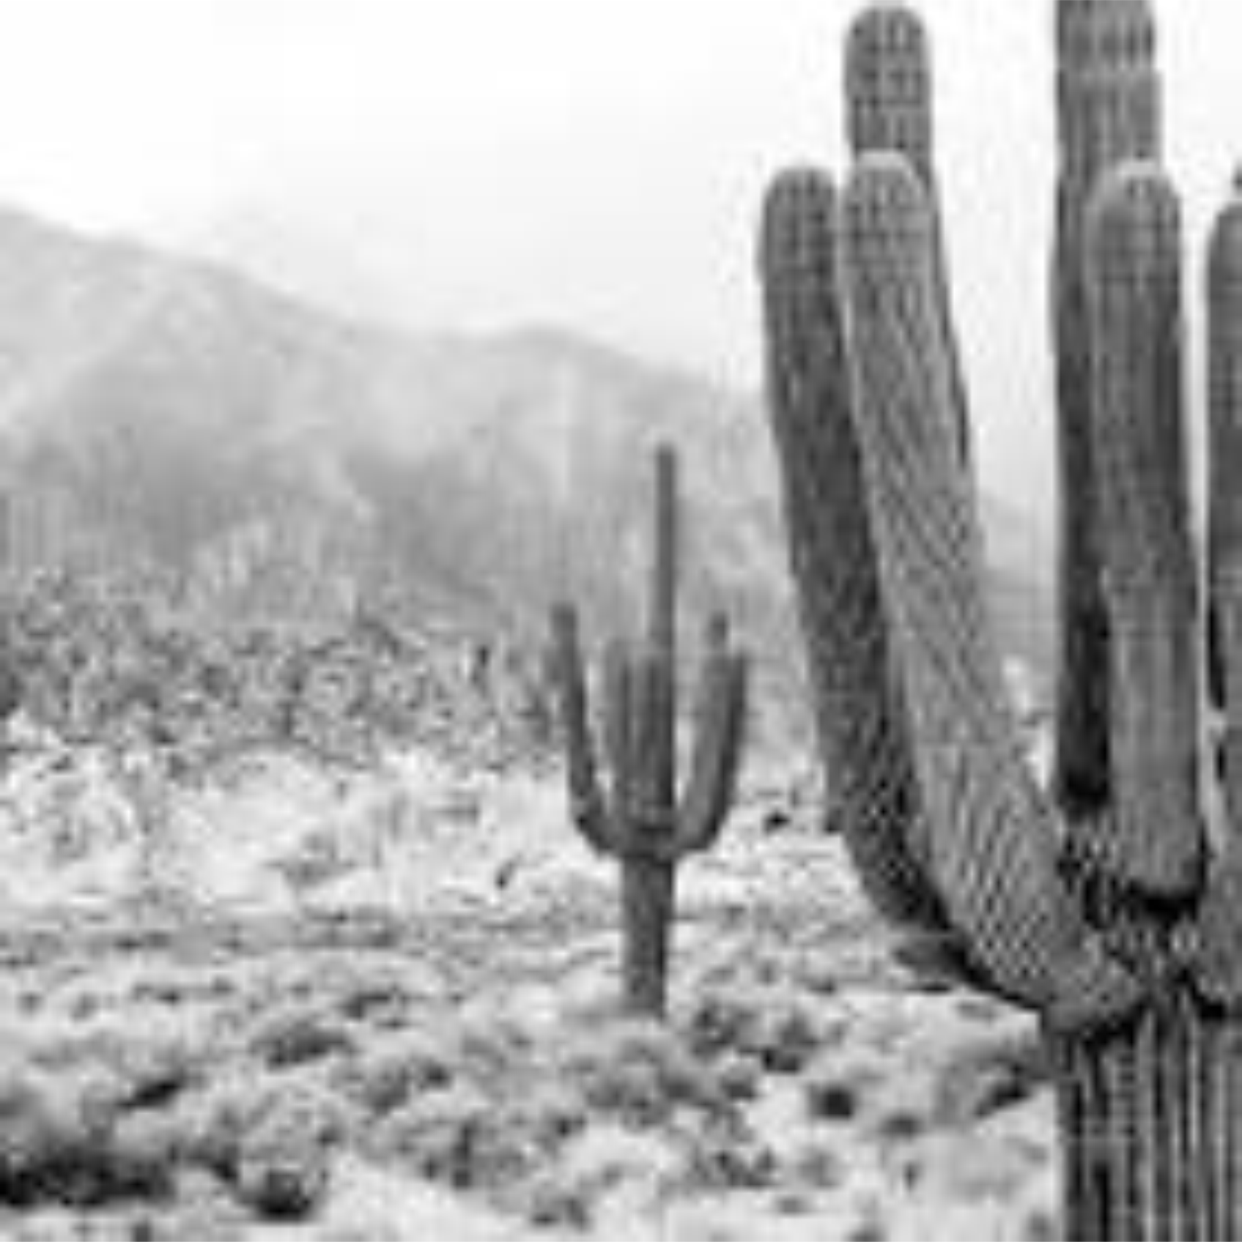

*Fig 5.13* cactus plant

**Mechanism of dark reaction in CAM:**

The mechanism of dark reaction in CAM is similar to that of C4 plants except that in CAM stomata closed during the day and open them only at night to minimize excess water loss, while C4 plants fix carbondioxide in the daytime.

**Similarities between CAM and C4 plants:**

1. Both CO2 fixations occur twice.
2. Both have two types of chloroplast, e.g. Bundle sheath and mesophyll.
3. Both have two types of enzymes.e.g, PEPase and RuBisco.
4. Both are efficient in photosynthesis.
5. Both can never undergo the process of photorespiration.

**Differences between CAM and C4 plants:**

1. CAM is found in succulent plants whereas C4 is found in tropical plants.
2. In CAM stomata open at night and close in the day whereas in C4 stomata open at day time and close at night.



**Sample question – 16**

**Mzumbe Gauging – 2005**

1. Briefly, explain what would be the effect of lowering oxygen concentration on:-
2. C3 photosynthesis.
3. C4 photosynthesis.
4. C4 plants are considered to be more efficient in photosynthesis than C3 plants, with reasons argue for or against.
5. Why is it a benefit that bundle sheath chloroplast lack grana?
6. How is CAM photosynthesis like C4 metabolism and how is it different?

**5.2.4. FACTORS AFFECTING THE RATE OF PHOTOSYNTHESIS:**

The factors affecting the rate of photosynthesis are explained by the **law of limiting factor** which was discovered in **1905** by the **Blackman;** this law states that:

*“The rate of a physiological process such as photosynthesis will be limited by the factor which is in shortest supply”.*

**The concept of limiting factor:**

**Limiting factor** is a factor at lowest supply in any chemical reaction involving several factors can prevent the rate of reaction, i.e. in photosynthesis there are several environmental factors that affect the rate; they include light intensity, carbondioxide concentration and temperature, in any given situation one of these factors may become a limiting factor.

**For example;**

**Case 1: Light intensity**

Low light intensity such as early morning or at evening will not provide sufficient energy to excite electrons or photolysis of water in light reaction, as the result no ATP and NADPH2 will be produces. In this situation light is said to be the limiting factor.

**Case 2: Carbondioxide concentration**

Low carbondioxide concentration (< 0.03%) will decrease efficiency of RuBisco enzyme in C3 plants for photosynthesis even if there is plenty of light. In this situation carbondioxide concentration is said to be limiting factor.

**Case 3:** **Temperature**

Temperature below optimum value (20ºC – 25 ºC) will not active RuBisco enzyme for fixing carbondioxide in the atmosphere even if plant has optimum light intensity and optimum carbondioxide level, in this situation temperature is said to be limiting factor.

**Sample question – 17**

**Style 1: Tahossa – 2020**

* The concentration of carbondioxide in atmosphere and light intensity often limit the rate of photosynthesis. Briefly explain what is meant by a limiting factor in relation to photosynthesis.





**Sample question – 18**

**Style 2: Tahossa Temeke**

* Suggest the conditions in which the following may be the limiting factors in photosynthesis:

1. Light intensity
2. Carbondioxide concentration
3. Temperature

**The illustration of limiting factor on the rate of photosynthesis:**

Consider the figure 1 below, which show the effect of limiting factor on the rate of photosynthesis:

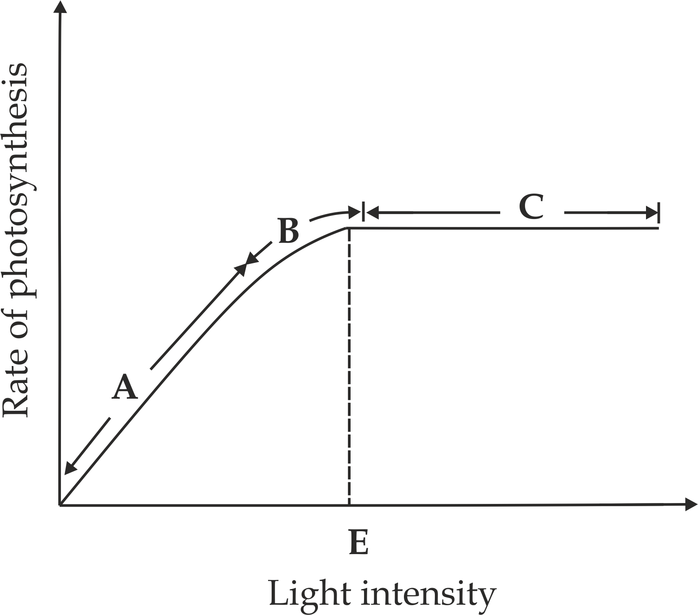

***Figure 5.14*** limiting law

**Interpretation:**

**Point A:** Light intensity was a limiting factor, it was in short supply and thus the rate of photosynthesis was still low, as light kept on increasing. The rate of photosynthesis increased too, up to point **B** where it started to plateau despite the fact that light intensity was in plenty supply.

**Point B**: Another factor other than light intensity became the limiting factor too. Hence, both light intensity and the other factors were the limiting factors at this point.

**Point C**: light intensity was no longer a limiting factor.

**Point E:** Is the light saturation point beyond which an increase in light intensity causes no more increase in the rate of photosynthesis.



**Sample question – 19**

**Style 1: Famous question**

* Study the graph below and answer the questions which follow:

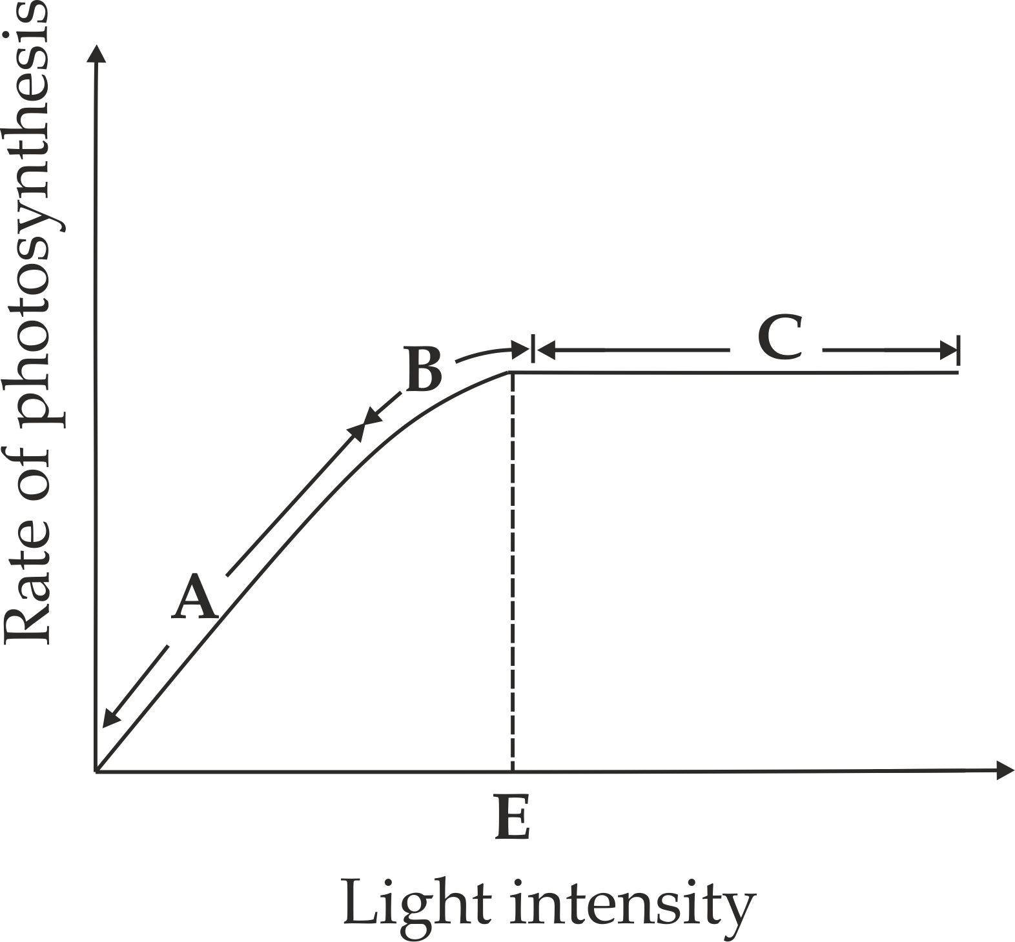

1. What is limiting factors in region **A**?
2. What is represented by curve at **B** and **C**?
3. What does point **D** represent on the curve?

**Style 2: Feza Boys 2018**

* What is a limiting factor, illustrate your answer.

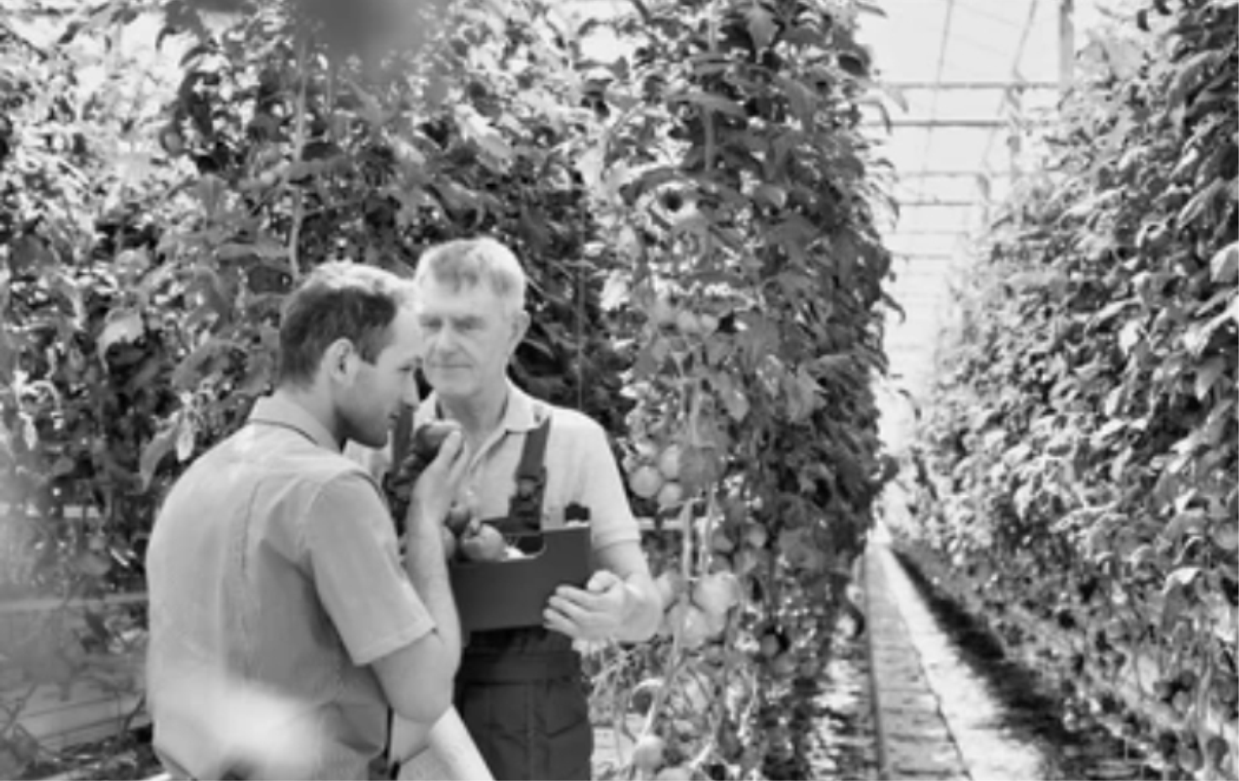

***Fig 5.15*** *The green house farm*

**Application of limiting factor in green houses:**

Farmers (*5.15*) apply the knowledge of limiting factor to increase crop growth in green houses. For instance; in order to prevent light intensity from being a limiting factor, farmers in green houses use artificial light so that photosynthesis can continue beyond daylight hours or in a higher than normal light intensity.

The **process of photosynthesis** is usual influenced by both internal and external factors.

1. **External factors**

The external factors are also termed as environmental factors which include; light, carbondioxide concentration, water, , temperature, wind as well as minerals.

1. **Light**

The effect of light on the rate of photosynthesis can be described on the basis of its quality (light wavelength) and quantity (light intensity).

* **Light quality (wavelength of color)**

Photosynthesis usually occurs when green plants absorb light within a limit of visible light spectrum. The most effective range is within a red – orange band (600 – 700 nm) and a blue – violet band (400 – 500 nm). The central band is also effective, but less than others because the chlorophyll molecules show very little absorption of light in this region. Maximum light absorption corresponds to the maximum rate of photosynthesis.

* **Light intensity (quantity)**

The rate of photosynthesis usual varies proportionally to light (*5.16*). However, at a certain point called **saturation point**, the rate of photosynthesis normally reaches its maximum and therefore attains constancy. Any further increase in light intensity brings no effect on the rate of photosynthesis, if other factors are limiting; However, unless the plant is adapted to high light intensity.

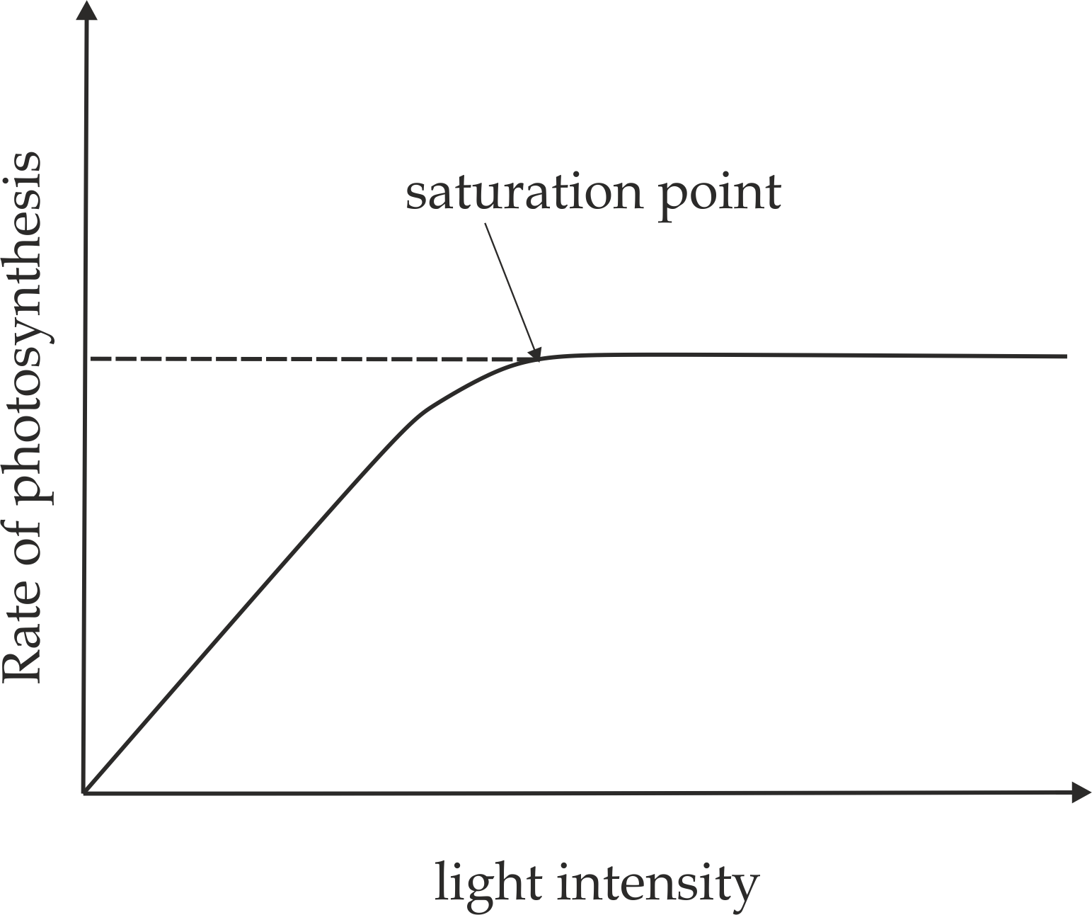

***Figure 5.16*** *The effect of light on the rate of photosynthesis*

1. **Carbondioxide concentration**

The normal average level concentration of carbondioxide in the atmosphere is about 0.03%. As the concentration of carbon dioxide increases the rate from the average value, it also increases the rate of photosynthesis; however too much carbondioxide concentration above 0.1% can damage plant leaves. On the other, low carbondioxide tend to limit the rate of photosynthesis. It should be noted that, C3 plants are affected by low concentration of carbondioxide in the atmosphere, while C4 plants are efficient in utilizing carbondioxide even when the concentration in the atmosphere is low.

1. **Water**

Water is one essential raw material for photosynthesis. It also plays other roles in the plant body such as translocation of minerals and gases as well as products of photosynthesis. Shortage of water leads to wilting of plant leaves which in turn causes closing of the stomata; This result into a reduced diffusion rate of carbon dioxide into the chloroplast and hence decreased rate of photosynthesis. Additionally, water shortage causes cells to become flaccid; thus they cannot function well and this affects the translocation of synthesized products.

1. **Temperature**

Within the optimum temperature, the rate of photosynthesis tends to double for every 10℃ rise of temperature. For example, the optimum temperature for plants that survive in temperate climates is 25℃. The temperature above 35℃ usually causes denaturation of enzymes catalysing photosynthesis in both, dark and light reactions, leading to slowing down or stopping of photosynthesis. In low temperature such as below 10℃, enzymes catalysing photosynthesis become inactive hence lower its rate.

1. **Wind**

Wind moving at high speed reduces the rate of photosynthesis because strong wind usually facilitates transpiration and hence affects the availability of water. Therefore, speedy wind reduces the amount of water available as the raw materials for photosynthesis, and thus reduces the rate of photosynthesis.

1. **Minerals**

Minerals such as magnesium and iron are components of chlorophyll. Deficiency of these minerals reduces the rate of photosynthesis because plant lacks enough chlorophyll molecules for trapping light energy.

1. **Internal factors**

The internal factors which are also called plant factors are size/ shape of leaves, amount of chlorophyll, enzymes and inhibitors.

1. **Size/ shape of leaves**

The broader the leaf more amount of light captured and thus the higher the rate of photosynthesis and vice versa is true.

1. **Amount of chlorophyll**

Chlorophyll is responsible for trapping light energy during light reaction. When chlorophyll concentration in the leaves is very low, the rate of light reaction will be reduced because only a little amount of light will be trapped for the reaction, resulting in reduction in the rate of the photosynthesis.

1. **Enzymes**

Photosynthesis is an enzyme controlled process. If the enzymes are inactive, the rate of photosynthesis proceeds very slowly; In contrast, when the enzymes are very active, the rate of photosynthesis becomes very high.

1. **Inhibitors**

An inhibitor is a substance or factor which may slow down the rate of reaction. For example many herbicides interfere with the electron flow in the chloroplast; thus inhibits the light reaction, and hence no photophosphorylation.

**Sample question – 20**

**Style 1: Tahossa 2020**

* Briefly explain how inorganic ions, inhibitors, light intensity and light quantity affect the rate of photosynthesis.

**Style 2: Necta 2015**

* Write a balanced equation of photosynthesis and from the equation, state which factors and conditions are likely to affect the rate of photosynthesis.



**5.3: ANIMAL NUTRITION**

Nutrition in animals concentrates on the process of **digestion,** which include the following main aspects:

* Introduction of digestion
* Digestion in the buccal cavity (mouth)
* The Oesophagus
* The stomach
* The small intestine
* Duodenum
* Jejunum
* Ileum
* The large intestine
* Caecum and appendix
* Colon
* Rectum
* Anus
* Nervous and hormonal control of the digestive juice
* Common disorders of the digestive system

**5.3.1: INTRODUCTION OF DIGESTION**

**Digestion:** refers to a process of breaking down large biochemical compound contained in food into smaller and soluble molecules that can easily be absorbed into the body. It involves mechanical and chemical digestion.

1. **Mechanical digestion**

It involves the physical break down of the food into small pieces; this type of digestion is brought about by **three (3)** main ways:

* **Mastication(chewing)**

It is the physical breaking down of food by the action of teeth in the buccal cavity.

* **Churning**

It is the physical breaking down of food by the action of gut muscles such as in peristalsis of food along the oesophagus.

* **Emulsification**

It is the physical breaking down of food by the action of bile such as breaking down of fats into fat droplets in the duodenum.

**Why mechanical digestion is important?**

1. It breaks down food compound into small pieces, making it easier for them to be swallowed.
2. It increases the surface area available for the enzymes to act on.
3. **Chemical digestion**

It involves the breakdown of food by using chemical substances known as **digestive enzymes**. Chemical digestion may be **intracellular**; occurring within the cell, as in the protoctists and other small organisms which survive by the heterotrophic nutrition. However, in the larger heterotrophic organisms, including the mammals, digestion is mainly **extracellular,** with the digestive enzymes working in a specialized environment known as the **alimentary canal** or **gut** shown in Fig *5.17*.

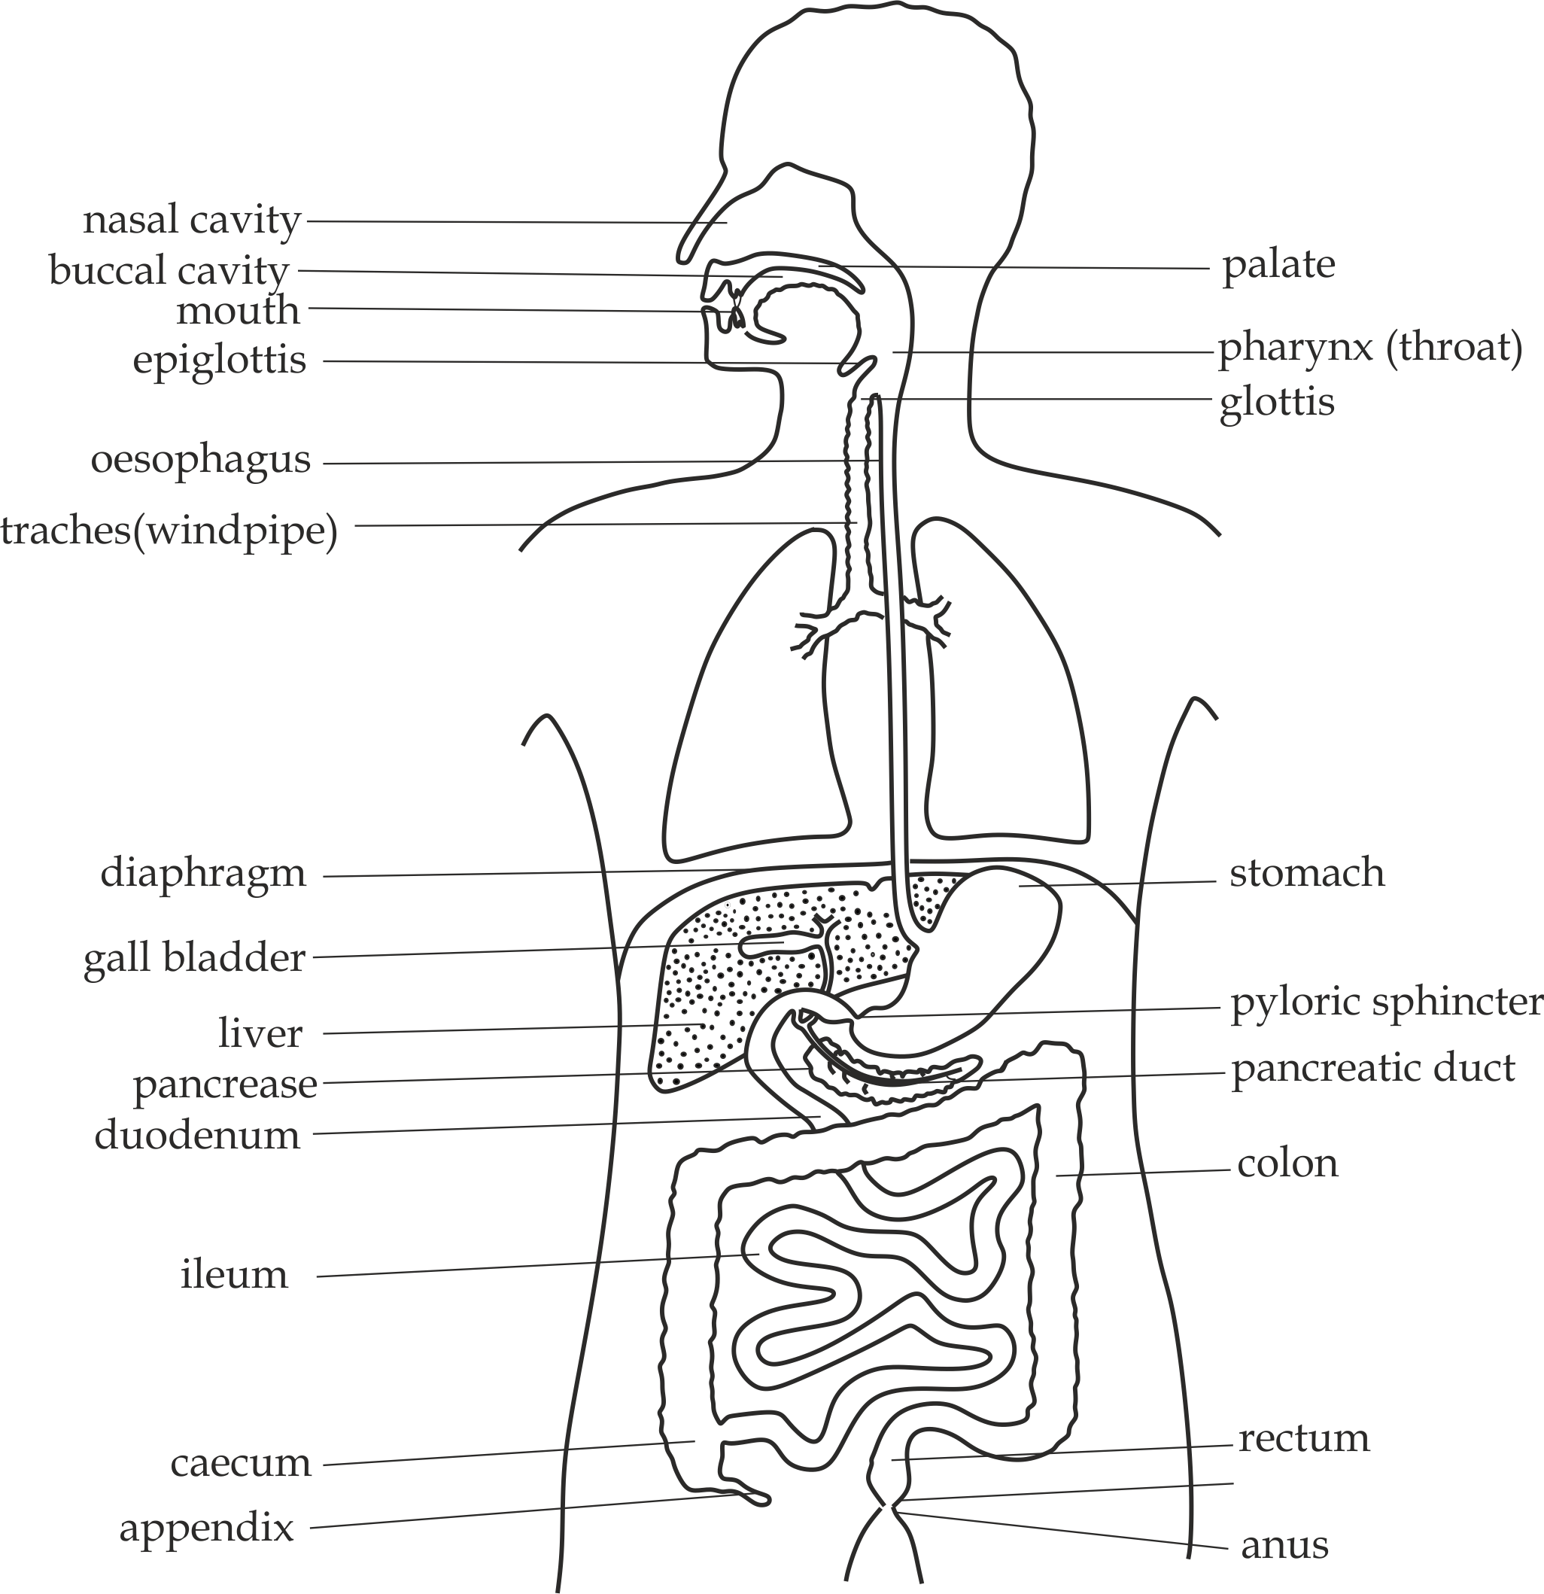

***5.17*** *The parts of the alimentary canal*

**The structure of human alimentary canal (gut)**

The many differentiated regions of the human gut all possess the same general structure. This consist of four (4) distinct layers which include; mucosa, sub mucosa, muscularis externa and serosa as shown in *Fig 5.18*.

1. **Mucosa**:

This is the glandular innermost layer of the gut which secreting mucus and a variety of enzymes; the mucosa layer consists of sub – layers which include;

* **epithelium layer** which lining the surface of lumen and invaginating to form glands which secrete mucus and enzymes, some of the epithelial cells have microvilli on their surface membranes which form brush borders.
* **Lamina propria** it forms the basement membrane under which epithelial cells rest.
* **Muscularis mucosa** it is a thin layer of smooth muscles outside the lamina propria, it produces folds of the mucosa in some regions of the gut.

1. **Sub mucosa:**

This is layer beneath the mucosa layer consisting of connective tissues such as blood vessels, lymphatic vessels and nerve cells.

1. **Muscularis externa:**

This layer consist of inner circular (radial) muscles and outer longitudinal smooth muscles responsible for **peristalsis.** Circular muscle is specialized into sphincters at various points in the gut. *Auerbachs nerve plexus*, situated between the two muscle layers, control peristalsis. *Meissners nerve* plexus, located between the circular muscle and submucosa, controls glandular secretion.

1. **Serosa**

This is the outermost layer of the gut which comprises of loose fibrous connective covered by peritoneum. Peritoneum also forms mesenteries which hold and suspend the gut from the dorsal body wall.



**Remember!**

Normally the structure of gut differ in type of epithelium present in a region (it will be discussed in the concept of epithelium).

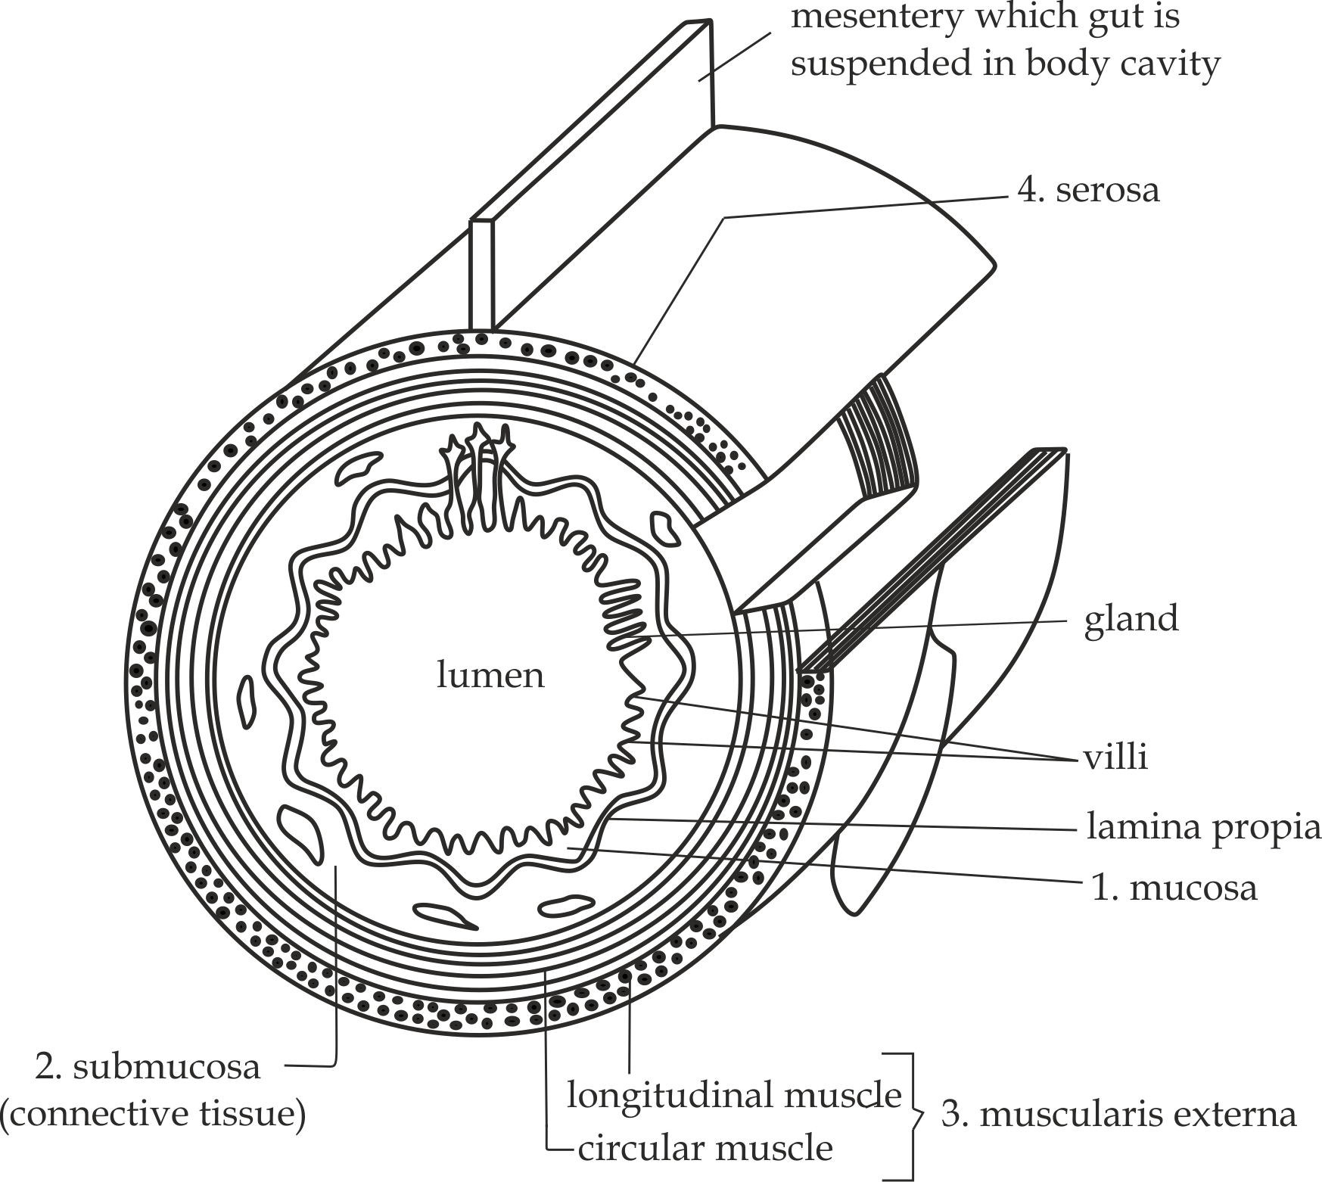

***5.18*** *Generalized structure of the gut wall*



**Sample question – 21**

**Mzumbe Gauging 2003**

* Describe the generalized structure of human gut wall.

**Site of enzyme secretion**

Enzymes are secreted by the epithelial tissues in the mucosa layer of the digestive system. **Epithelial tissues** are tissues which form glands, cover all the body cavities and surfaces. In this section; we will discuss only the epithelial tissues which associated with digestive system. The epithelial tissues associated with digestive system includes; stratified, columnar, cuboidal and glandular epithelium.

1. **Stratified epithelium**

It is a tissue which contains several layers of cells; the outer layer is called stratum corneum with dead cells whereas the inner layer is called stratum germinum whose cells are actively multiplied as shown in *Fig 5.19*. It is found in thebuccal cavityandOesophagus.

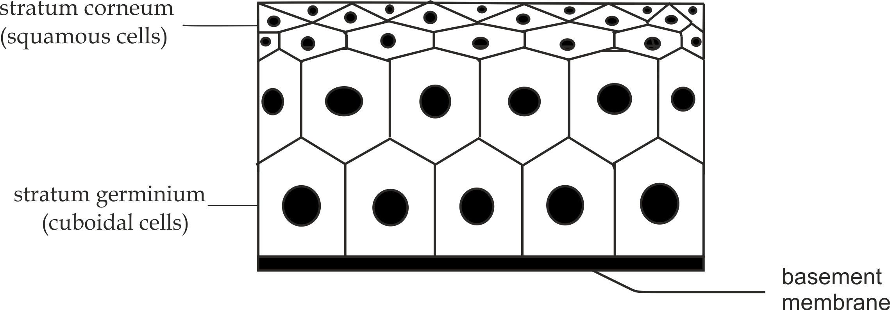

***5.19*** *stratified epithelium*

**Adaptive function of stratified epithelium:**

1. It is thick and tough to protect the digestive mucosa from abrasion against swallowed food.
2. **Columnar epithelium**

It is a tissue which contains tall and narrow cells with nuclei at their basal ends. It also contain microvilli and goblet cells as shown in *Fig 5.20*. It is found in the stomach and small intestine.

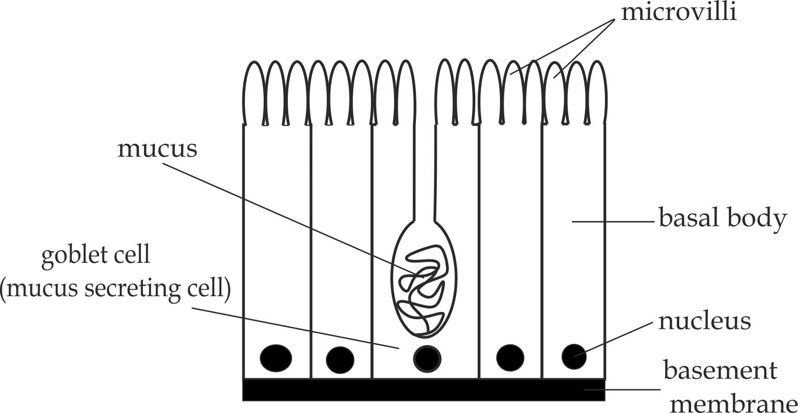

***5.20*** *Columnar epithelium*

**Adaptive functions of columnar epithelium:**

1. It has tall and narrow cells which provide surface area to volume ratio for absorption of the end products of digestion.
2. It has goblet cells which secrete mucus to protect the digestive mucosa from being self-digested (auto digestion) by the enzymes and Hcl.
3. It has microvilli which increase surface area for absorption of the end products of digestion.
4. **Cuboidal epithelium**

It is a tissue which contains cube shaped cells with central nuclei as shown in *Fig 5.21*. It is found in ducts of many glands such as salivary gland and pancreatic duct.

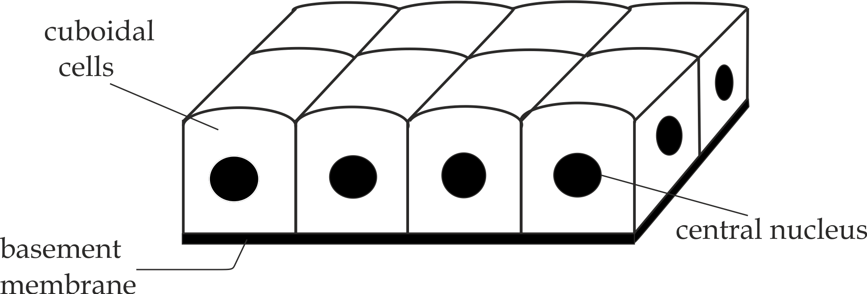

***5.21*** *Cuboidal epithelium*

**Adaptive function of cuboidal epithelium:**

1. It forms lining of many ducts such as pancreatic ducts.
2. It may also be secretory, For example; salivary gland which secrete saliva.
3. **Glandular epithelium**

It is epithelium tissue which contains secretory cells which secrete materials such as mucus into cavity or space lined by it. For example, in the stomach and the small intestine the mucus protects and lubricates the lumen of the intestine and stomach against self-digestion by its enzymes.

Examples of glandular epithelial tissues found in the digestive system include **simple tubular gland** such as Crypts of Lieberkhun found in the intestines, simple **branched tubular glands** such as gastric glands found in the stomach walls (gastric mucosa), and **compound tubular** such as Brunner’s gland in the intestinal wallsand **compound saccular** **glands** of salivary glands as shown in *Fig 5.22*.

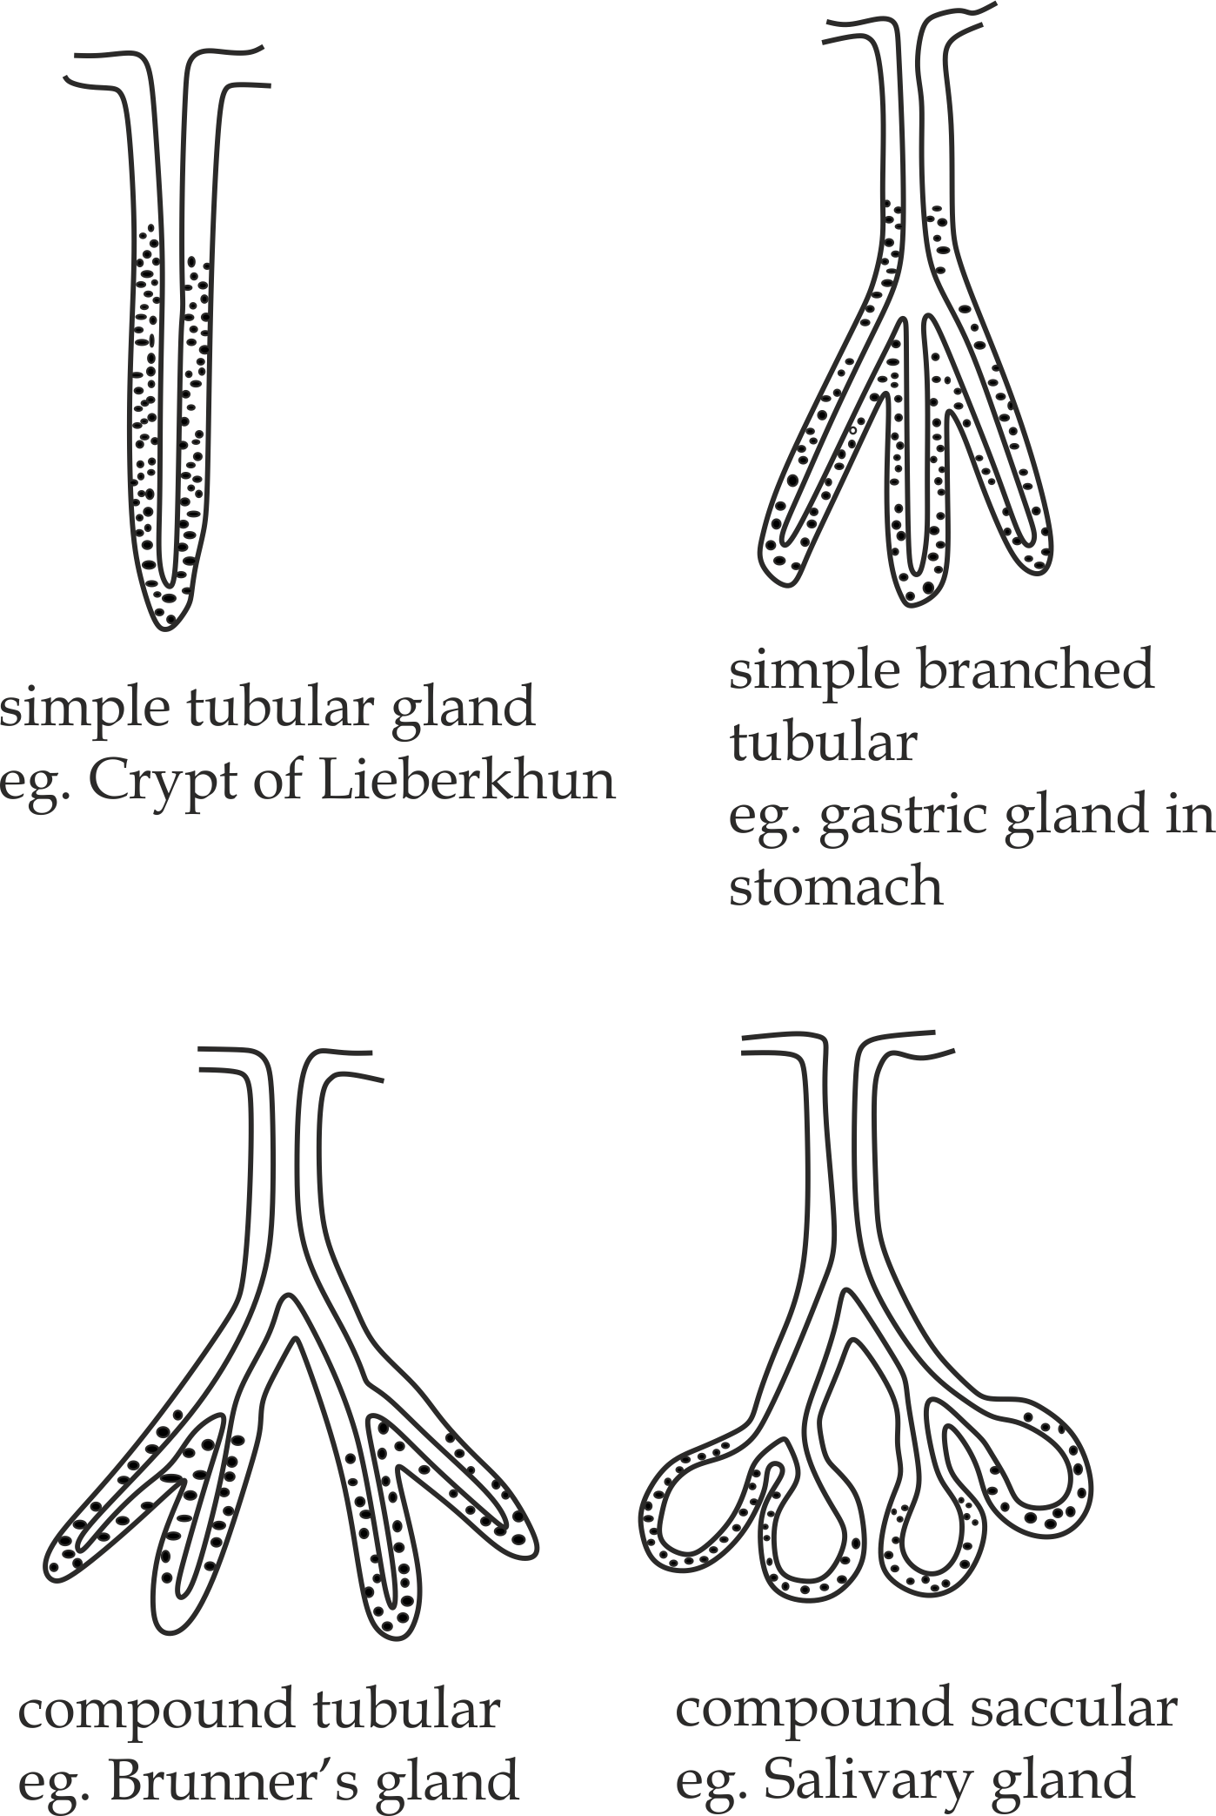

***5.22*** *Glandular epithelium associated with digestive system*

**Adaptive functions of the glandular epithelium:**

1. They contain secretory cells that are closely packed that secrete mucus into the cavity.
2. They are folded in various ways to form glands.

**Sample question – 22**

**Style 1: Necta 2006**

* With the aid of diagram discuss the relationship between structure and function of the epithelial tissues involved in digestion.

**Style 2: Mock Temeke region 2021**

* Explain how glandular and columnar epithelium tissues of the alimentary canal are adapted to the functions they perform



**Causes of enzyme secretion:**

The production of digestive enzymes in mammals is induced by the following causes:

1. **Sight of food (Presence of food)**

This refers to the time which always a person used to get food, this time become conditioned reflex action once reach that time the brain allow secretion of digestive enzyme regardless the food is present or not.

1. **Smell of food**

The smell of food stimulates the receptors of the tongue and nose, this brings about the secretion of digestive enzymes.

1. **Taste of food**

Taste of food stimulates the receptors of the tongue to initiates nerve impulse transimittion to the brain, hence cause the secretion of digestive enzymes.

1. **Thought of food**

Thinking of kind of food stimulates the brain, this brings about the secretion of digestive enzymes.

**Sample question – 23**

**Pre – National 2022**

1. Examine any four (4) reasons, how the production of digestive enzymes in mammal is induced.
2. Classify the simple epithelial tissues of the epithelium by identifying their location in the body.



**5.3.2: DIGESTION IN THE BUCCAL CAVITY (MOUTH)**

In the buccal cavity, the food is subjected into two (2) types of digestion includes; mechanical digestion due to the action of teeth on food (mastication) and chemical digestion due to the action of digestive enzymes on food.

**Chemical digestion in the buccal cavity:**

**Digestive gland:** Salivary gland

**Digestive juice:** Saliva

**Composition of saliva:**

About 1.5 dm3 of saliva is secreted from the salivary glands into the mouth each day. Saliva contains the following chemical components:

* **Water (99%)**

It moistens and dissolves the food.

* **Mucus**

It binds the chewed food together into bolus.

It lubricates the bolus for ease swallowing.

* **Electrolytes (Nacl)**

It maintains optimum pH (6.5 – 7.5) for the action of salivary amylase.

* ** – amylase**

It hydrolyses starch into maltose.

* **Lysozyme**

It kills bacteria which might be contaminated with food.



**Sample question – 24**

**Feza boy’s sec school, Saturday test – 2011**

* Suggest the name of a digestive juice in the buccal cavity, outline its components and the role(s) of each component.

**Adaptations of buccal cavity**

The buccal cavity has the following adaptive features for proper functioning:

1. It consists of muscular tongue which roll the food into bolus for easy swallowing.
2. It consists of stratified epithelium which prevents from the abrasion of swallowed food.
3. It consists of teeth for mechanical digestion of food.
4. It consists of 3 – paired of salivary glands which secrete salivary juice which contains salivary amylase ( – amylase) to hydrolyse starch into maltose.
5. It consists of tongue with taste buds sensitive to sweet, salty, sour and bitter taste.

**Sample question – 25**

**Dar Mock 2018**

* Explain four (4) adaptations of the buccal cavity in relation to its function.



**Swallowing**

The tongue which is located at the back of the buccal cavity rolls the food into a ball – like structure called bolus and forces it against the soft palate to the pharynx which initiates tactile swallowing reflex, in which the upward movement of the soft palate closes off the nasal cavity so that the food does not return down the nose and also larynx (voice box) is closed by a flap like structure called epiglottis so that the food does not enter the trachea. Then the bolus enters the oesophagus as shown in *Fig 5.23*.

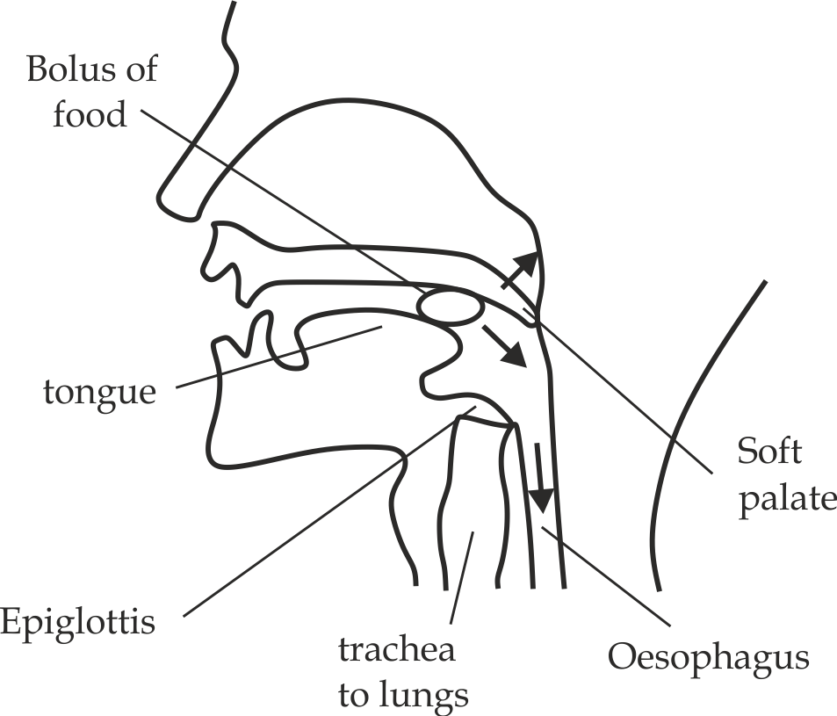

***5.23*** *Swallowing of the bolus food*

**5.3.3: THE OESOPHAGUS**

The oesophagus is a straight, narrow and thick – walled muscular tube about 25 cm long, leading from the pharynx to the stomach.

**Roles of oesophagus:**

1. It facilitates the passage of bolus food from the pharynx into the stomach by a series of wave like movement caused by involuntary contraction and relaxation of its circular and longitudinal smooth muscles. This process is described as **peristalsis**.
2. The peristalsis waves of contraction in the oesophagus also assist in mechanical digestion.

**The concept of peristalsis:**

**Peristalsis** is a series of wave like movement caused by involuntary contraction and relaxation of its circular and longitudinal smooth muscles.

**Mechanism of peristalsis:**

Behind the bolus food, the **circular muscles** (inner muscles) contract causes the oesophagus to become narrow, long and squeezing the gut whereas in front of the bolus food the **longitudinal muscles** (outer muscles) contract causes the oesophagus to become wide and short, In so doing; the bolus is pushed downward into the stomach as shown in *Fig 5.24*.

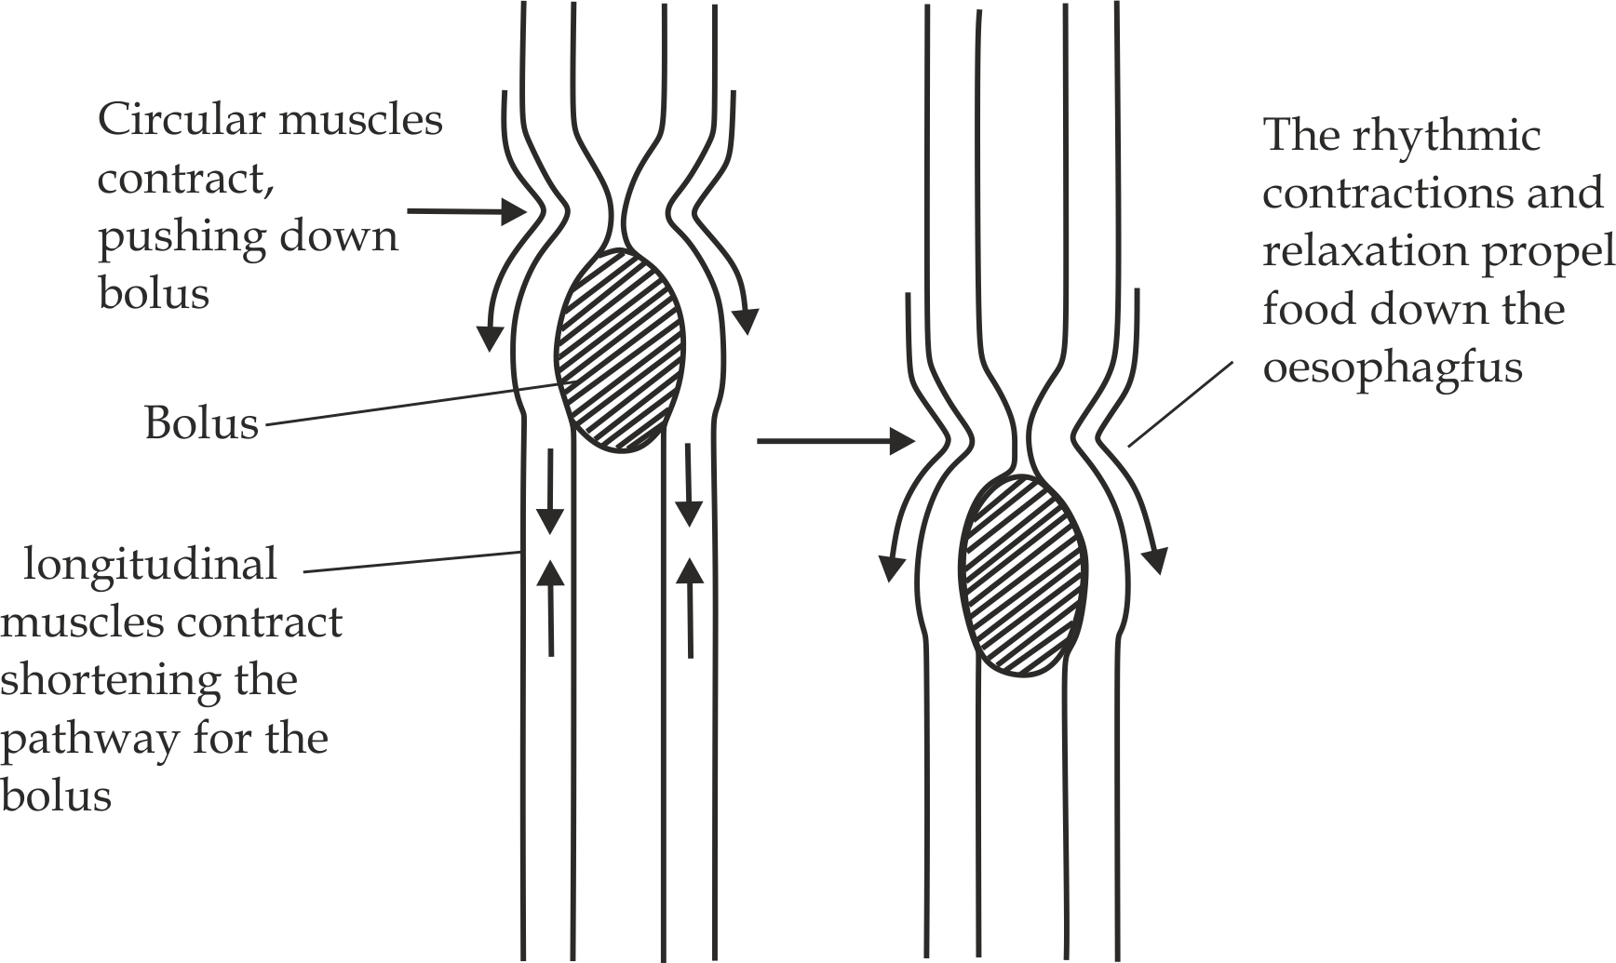

***5.24*** *Wave of peristalsis in the oesophagus*

**5.3.4: THE STOMACH:**

The **stomach** is a J – shaped muscular bag located high in the abdominal cavity, on the left – side just below the diaphragm. It has two valve – like rings of smooth muscles called **sphincters** that can open and close. One sphincter is called **cardiac sphincter**, it is located between the oesophagus and the stomach. The second sphincter is called **pyloric sphincter**, it is located between the duodenum and the stomach. The stomach wall consists of a layer of mucous membrane called **gastric mucosa**, it is highly folded and contains small pits called **gastric pits** leading to **gastric glands**, in which gastric juice is secreted as shown in *Fig 5.25*.

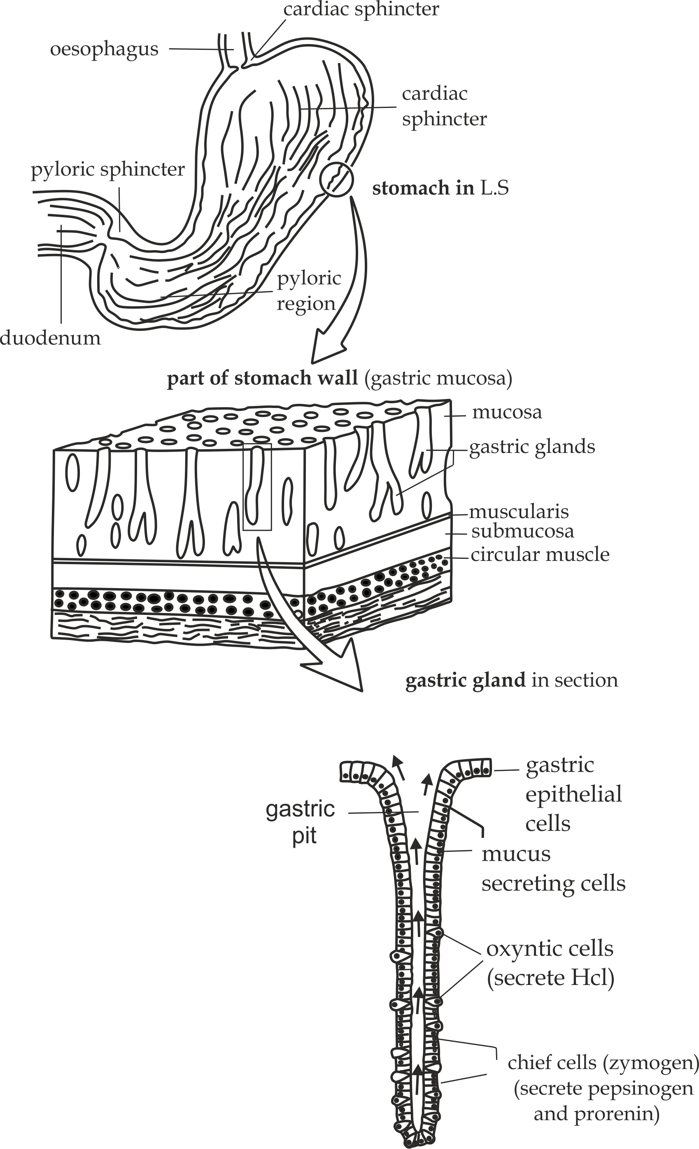

***5.25 The human stomach:*** *its wall and glands*

**Chemical digestion in the stomach:**

**Digestive gland:** Gastric gland

**Digestive juice:** Gastric juice

**Composition of gastric juice:**

* **Water**

1. It dissolves and solubilizes other components of the juice.

* **Hydrochloric acid (Hcl)**

It is produced by the Oxyntic (parietal) cells

1. It kills bacteria contaminated with food.
2. It activates pepsinogen and pro renin into pepsin and renin respectively.
3. It begins hydrolysis of sucrose.
4. It splits nucleoproteins to nucleic acid and protein.
5. It provides best PH (around pH of 2) for enzymes in the stomach to work best.

* **Mucus**

It is produced by goblet cells

1. It protects the layer on the stomach wall and glands from being self-digested (autolysis) by Hcl and pepsin.

* **Pepsin**

It is produced by the zymogen or chief cells; Pepsin is secreted in inactive form pepsinogen which is activated by hydrochloric acid. Why is pepsin secreted in an inactive form? The reason is that it is a protein – digesting enzyme and this prevents gastric glands being destroyed by its own enzyme (autodigestion).

1. It hydrolyses protein into peptides.

* **Renin**

It is produced by the zymogen or chief cells; Renin is also secreted in inactive form Prorenin which is activated by hydrochloric acid.

1. It coagulates soluble milk protein (casein) into insoluble milk protein (caseinogen).

**Remember!**

The coagulated milk is semi solid and it can be retained in the stomach for a relatively long time than the liquid milk for proper digestion. This is very important especially in lactating young mammals.



**General functions of human stomach:**

1. It acts as a temporary food storage organ, i.e. Food stays in the stomach on average for about 4 hours, although this depends on the type of food taken in. Liquid is retained for a much shorter time, while fatty meal will remain longer.
2. It provides chemical digestion of proteins due to the presence of pepsin enzymes.
3. It provides mechanical digestion due to contraction of stomach wall through churning.
4. It provides protection due to the action of hydrochloric acid.
5. It absorbs some materials such as water, ions, alcohol and some drugs such as aspirin.

**Sample question – 26**

**Style 1: Dar – Mock 2017**

* Why is it necessary for pepsin to be secreted in an inactive state?

**Style 2: Dar Mock 2019**

1. Explain four (4) functions of a human stomach.
2. Explain why fats/ oil meal delay stomach emptying?

**Hints (b)**

Fatty or oil meal stimulates the secretion of gastro inhibitory peptide (GIP) hormone by duodenal wall which inhibits gastric peristalsis thus delay stomach emptying.

**Style 3:** **Tahossa 2016**

A man can survive if his stomach is surgically removed, but he cannot survive if his liver is removed. Explain why?

**Hints:**

This is because a stomach can act as a temporary storage of food and all enzymes which are found in the stomach are also found in the duodenum, hence removal of stomach has no effect, while removing of liver can lead into death, because, there is no other organ which can perform the functions of the liver.



In the stomach, the food is folded into semi solid substance called **chyme**. Once the stomach has turned all the food to chyme; the contraction of stomach wall and periodic relaxation of the pyloric sphincter muscles permits successive small quantities of chyme to pass into duodenum, until the stomach is empty.

**5.3.5: THE SMALL INTESTINE**

The **small intestine** is the longest of all parts of the alimentary canal. In human, it has the length of about 9 metres in a living person. The small intestine is not straight but rather a coiled tube which literally has three major distinct regions namely; duodenum, jejunum and ileum.



**Did you know?**

***The small intestine in a dead person is about twice as much longer as its normal size in a living person, because death makes the small intestine to lose its muscle tone and stretches as it become loose.***

1. **Duodenum:** This is the initial part of the small intestine immediately bordering with the pyloric sphincter of the stomach on the proximal side and with the jejunum on the distal end.

**Chemical digestion in the duodenum:**

The duodenum receives secretion from pancreas and liver

1. **Liver:**

The liver produces a secretion called bile which is released into duodenum via the bile duct from the gall bladder.

**Composition of bile:**

* **Mineral salts (NaHCO3)**

It neutralizes acidic chyme from the stomach so as to provide alkaline PH for pancreatic enzyme.

* **Bile salts (sodium taurocholate and glycocholate)**

It emulsifies fat into fat droplets which increases surface area for easy hydrolysis by the lipase enzyme. The bile salts themselves are not enzymes; they also have no chemical effect on the fats, only the physical effect of emulsifying them.

* **Bile pigments (bilirubin and biliverdin)**

Bacteria in the alimentary canal changes these pigments into colouring matter which gives colour to the faeces.

**Sample question – 27**

**Style 1: Kilimanjaro Mock – 2020**

1. Liver as accessory gland of digestive system play various roles, one of them being secretion of bile which has several roles. Briefly explain four (4) roles of bile as used in digestion process.
2. What would happen to the activities of the intestinal enzymes if PH in the intestine remains at 2?

**Style 2: Dar Mock 2015**

* Bile is not a digestive enzyme; what is it? State its function in digestion.

**Hints:**

Bile is a yellow – green, mucous fluid containing bile salts, bile pigments and cholesterol.

Roles:

1. It emulsifies lipids, breaking them down into minute droplets.
2. Alkaline PH for pancreatic enzymes.
3. Give faeces its colour as it helps removing excretory product like bile pigments.
4. Some bile salts are necessary for absorption of vitamin K.
5. It stimulates peristalsis movement.

**Style 3: Dar mock 2021**

* An individual has a problem of liver cirrhosis to the extent that almost the whole liver is affected. Explain the problem encountered by this individual related to digestion. (Give four (4) points).

Hints: Oppose the roles of bile; start with, there will be no …………………………….



1. **Pancreas**

The pancreas produces a secretion called pancreatic juice which is released into duodenum through the pancreatic duct.

**Composition of pancreatic juice:**

* **Mineral salts (NaHCO3)**

It neutralizes the acidic chyme from the stomach so as to provide best PH for pancreatic enzymes.

* **Proteases**

These are protein – digesting enzymes, they normally include trypsinogen, chymotrypsinogen and carboxypeptidase.

1. **Trypsinogen**: This is inactive form trypsin which is converted into active form called trypsin by enterokinase enzyme secreted by the intestinal wall. Trypsinogen hydrolyses protein into peptides.
2. **Chymotrypsinogen**: This is inactive form of chymotrypsin which is converted into active form called chymotrypsin by trypsin enzyme. It hydrolyses protein into peptides.
3. **Carboxypeptidase:** It hydrolyses peptides into dipeptides and amino acids.

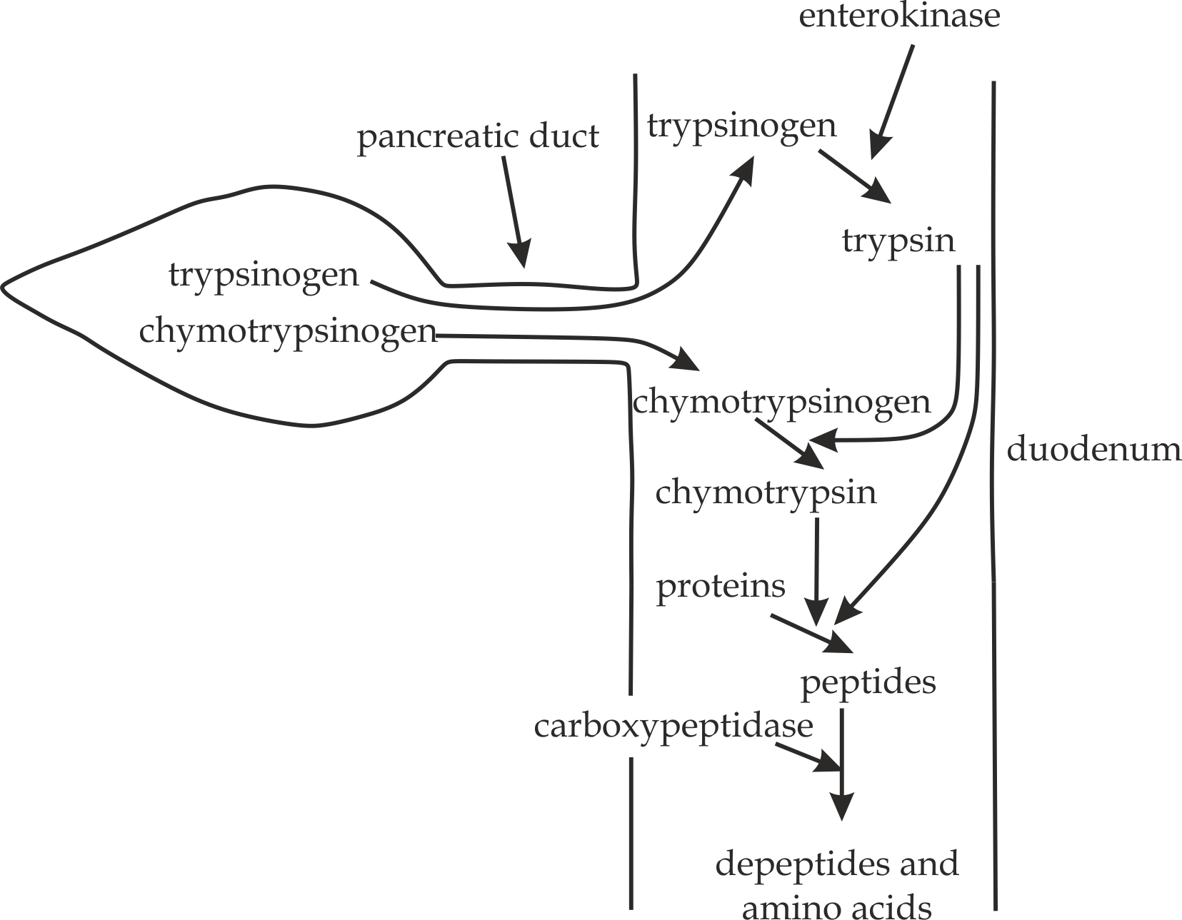

***5.26*** *action of proteases in the duodenum*

* **Pancreatic amylase**

It hydrolyses starch into maltose.

* **Pancreatic lipase**

It hydrolyses fat into fatty acids and glycerol.

* **Nucleases**

It hydrolyse nucleic acid into nucleotides.

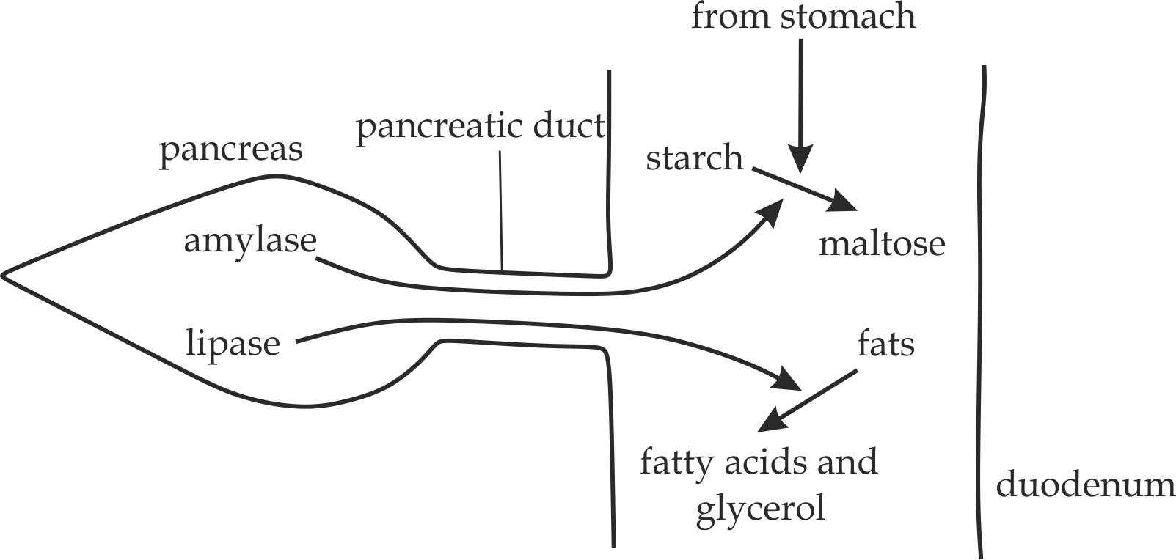

**5.27** *action of amylase and lipase in the duodenum*



**Sample question – 28**

**Simiyu sec school 2018**

1. The duodenum receives the secretion from pancreas and liver; list down the components of secretion from the pancreas and liver.
2. Describe how the flow of pancreatic secretion is controlled.
3. **Jejunum:** This is the second region of the intestine and middle portion of small intestine measuring approximately between 2 and 3 metres long. This region stretches from the duodenum and connect it with ileum. However there is no clear demarcation between jejunum and the ileum. It is responsible for nutrients absorption from the digested food to the blood stream with the aid of finger like structures known as villi. The absorbed materials are in form of minerals, proteins, carbohydrates and fats.
4. **Ileum:** This is the final section of the small intestine in most of high vertebrates including mammals, reptiles and birds. The ileum is the site for both, chemical digestion and absorption of nutrients.

**The ileum as the site of chemical digestion:**

**Digestive glands:**

Intestinal glands (Brunner’s glands and the crypts of Lieberkhun)

1. **Brunner’s glands**

It secretes mucus and sodium hydrogen bicarbonate (NaHCO3)

* **Mucus**

1. It protects the intestinal walls from autodigestion.
2. It lubricates the intestinal walls for smooth flow of food.

* **Sodium hydrogen bicarbonate (NaHCO3)**

1. It neutralizes the acidic chyme from the stomach and thus provide optimum PH for the intestinal enzymes to work effective.

**Sample question -29**

**Simiyu Mock 2018**

1. What are the two types of products of the Brunner’s gland of the small intestine?
2. State the roles of the products in (a) above.



1. **Crypts of Lieberkhun**

It secretes intestinal juice called saccus intericcus.

* **Erepsin**

These are protein – digesting enzymes in the ileum, they usual include aminopeptidase and dipeptidase.

1. **Aminopeptidase:**

This hydrolyses peptide into dipeptide and amino acid.

1. **Dipeptidase**

This hydrolyses dipeptide into amino acids.

* **Carbohydrases**

These are carbohydrates digestive enzymes in the ileum, they include amylase, maltase, lactase and Sucrase.

1. **Amylase:** It hydrolyses starch into maltose.
2. **Maltase:** It hydrolyse maltose into glucose.
3. **Lactase:** It hydrolyse lactose into glucose and galactose**.**
4. **Sucrase:** It hydrolyse sucrose into glucose and fructose.

* **Lipase**

It hydrolyses lipids or fats into fatty acids and glycerol.

* **Nucleotidase**

It hydrolyse nucleotides into pentose sugar, phosphate group and organic base.

* **Enterokinase**

A non – digestive enzyme which activates the trypsinogen produced by the pancreas into trypsin.

**Sample question – 30**

**Jecas 2011**

Digestion in mammalian gur relies on enzymes, copy and complete the table below which show the enzyme, site of origin and the products.

|  |  |  |  |
| --- | --- | --- | --- |
| No:- | Enzyme | Site of origin | Product(s) |
| (i) | Salivary amylase | Salivary gland |  |
| (ii) | Pepsin |  | peptides |
| (iii) |  | pancreas | Fatty acid and glycerol |
| (iv) | carboxypeptidase |  | Peptides and amino acid |
| (v) |  | ileum | Glucose and galactose |
| (vi) | Sucrase | ileum |  |



**The ileum as the site for absorption:**

While some absorption can occur along most sites of the alimentary canal, however ileum is the main site of absorption due to the following adaptive features as shown in figure as shown in *Fig 5.28*:

1. It is long, 6m in length, which provides enough time for end products of digestion to be absorbed.
2. It has villi which increase surface area for absorption of digestion products.
3. It has many folds, which slow down food and so increases the time for absorption.
4. It is well supplied with blood capillaries which carriers away absorbed materials hence maintains a concentration gradient for other materials to be absorbed.
5. It is supplied with lymphatic system which carriers away absorbed fatty acids and mono glycerides.
6. The epithelial cells contains numerous mitochondria for provision of energy necessary for active transport.
7. The epithelial cells are covered by brush borders. These microvilli increase surface area by 20 folds for absorption of digestion products.
8. It is able to contract and relax continuously, thus bringing themselves into close contact with food.

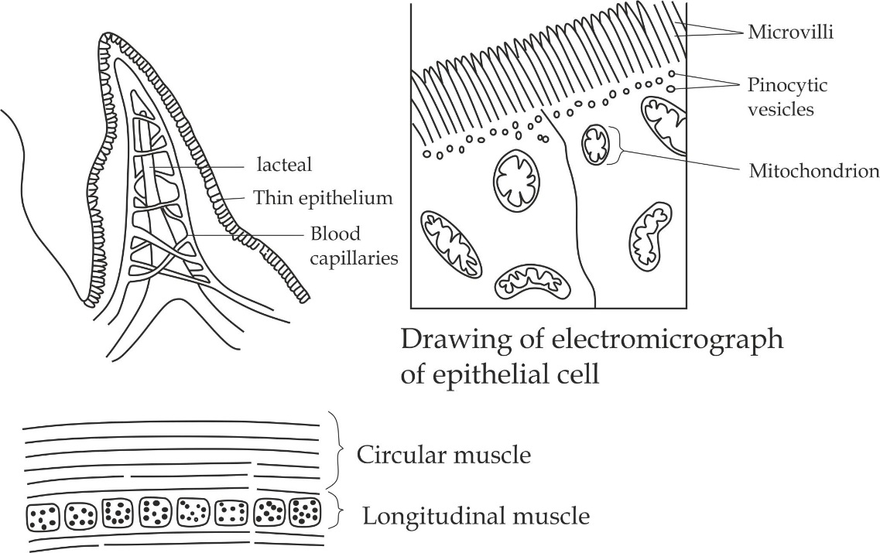

***5.28*** *Transverse section through mammalian ileum*

**Absorption of glucose and amino acids**

Blood capillaries absorb glucose and other monosaccharides, amino acids and dipeptides by facilitated diffusion and active transport from the epithelial cells of ileum into venule and finally reaches the **hepatic portal vein** where it flows to the liver as shown in figure.

**Absorption of fats**

Lacteal absorbs fatty acids and glycerol, it recombines them into lipids in the epithelial cells, which later combines with proteins to form lipo – protein molecules, called **chylomicrons.** These are transferred into the lacteal and finally to larger lymph vessels which carry them to the superior vena cava as shown in *Fig 5.29*.

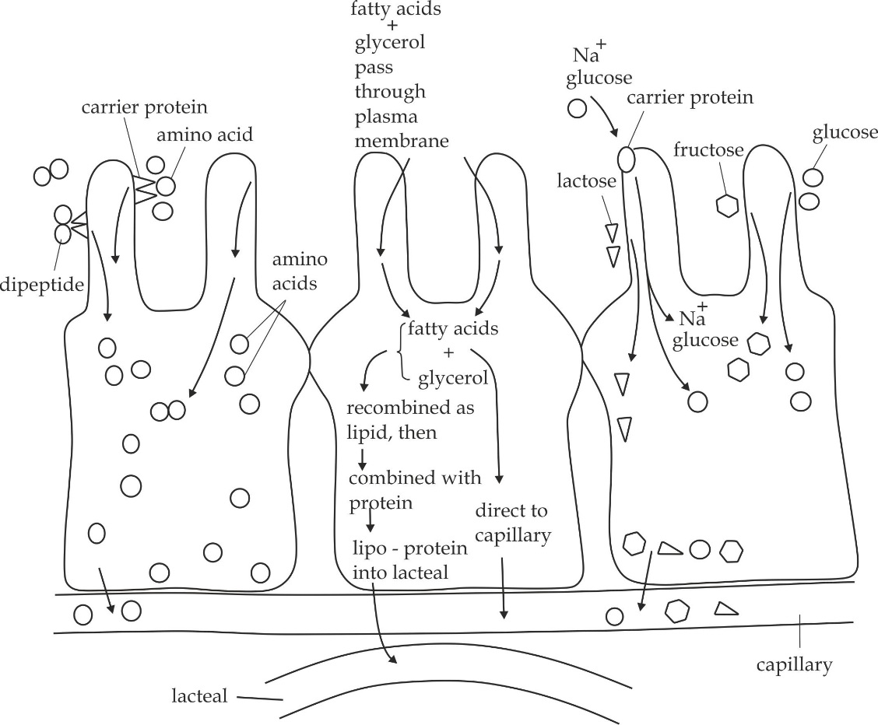

***5.29*** *Absorption of glucose, amino acids and fats in the ileum*



**Sample question 31**

**DAR MOCK 2017**

* Describe the roles of lacteal and blood capillaries in each villus of the ileum.

**5.3.6: THE LARGE INTESTINE**

This is the last part of the alimentary canal about 1.5 m long extends from a blind pouch called caecum through anus. The larger intestine differs in many ways from the small intestine; besides its diameter, which is relatively larger than that of small intestine; it has few enzymes secreting cells in its walls. The villi which are numerous in the small intestine are missing in the large intestine. The wall of the large intestine is thus simple in structure and has simple columnar epithelium. The intestinal mucus secreting glands are relatively more in number than they are in the small intestine. The mucus in the large intestine is important in lubricating the food residues moving out as faeces while also protecting the intestine from effects of acids and gases produced by enteric bacteria. The large intestine therefore, had four major regions, namely; caecum (appendix), colon, rectum and anus.

1. **Caecum and appendix**: These are sac like structures of about 6 cm suspended interior at the junction of small and large intestines. In non – ruminant herbivores mammals, such as the horse and rabbit, the **caecum** and **appendix** are relatively long structures and have an important role in cellulose digestion. In humans the caecum and appendix are short, and caecum is the first region of the large intestine where absorption of water and salts continued while the role of appendix is not clearly known hence it is considered as a vestigial organ. However, appendix is reported to have lymph nodes and may help to control intestinal pathogens.
2. **Colon:** This region of the intestine borders with caecum and it is made up of four sub regions namely the ascending, transverse, descending and sigmoid regions. Generally, colon is very important in the water balance of the body. It reabsorb water from undigested food and recycles it into the blood stream. It also contain bacteria such as *Escherichia coli* which synthesize biotin (a B vitamin) and vitamin K.



**Did you know?**

***Every day, about seven litres of water from drinks and watery secretions produced internally, reabsorbed in the gut into the blood stream. If most of these were not reabsorbed, it could lead to dehydration of the body.***

1. **Rectum:** After food residues have passed through the sigmoid colon, the remaining intestinal content is stored as faeces in the rectum which measures about 20 cm long. Rectum is located interior to the pelvis and it produces some mucus material which are added to the faeces in order to lubricate it foe easy passage to the outside by the process called defecation. The desire for defecation is caused by the presence of a large quantity of faeces in the rectum. The walls of the rectum have curved contours and lateral bends which create internal transverse folds called rectal valves. The function of these valves is to separate faeces from gas in order to prevent simultaneous passage of faeces and gas.
2. **Anus:** This region is also called anal canal and constituents the final part of the large intestine. The length of the anal canal is between 3.8 to 5 cm and it opens to the exterior of the body at the anus. It has two types of muscles; the internal anal sphincter and external anal sphincter. The former first type of muscle is made up of smooth muscles, and its contractions are involuntary, while the later is made up of skeletal muscles and they are under voluntary control. Under normal conditions, these two types of muscles make the sphincters remain closed except when **defaecating**.

**5.3.7: NERVOUS AND HORMONAL CONTROL OF DIGESTIVE JUICE**

Most digestive juice is secreted only when there is food in the gut. Coordination. Coordination of secretion with the presence of food involves the nervous and endocrine systems.

1. **Saliva**

It is secreted into the buccal cavity from salivary glands as induced by nervous system under two types of reflexes.

1. **Simple unconditional (inborn) reflex** which is induced by taste, smell, sight and presence of food in the mouth, contact of food with taste buds of the tongue stimulates receptors to sweet, salty, sour and bitter tastes. Sensory neurone carry nerve impulse from these receptors to the brain. From there, nerve impulses travel along motor neurone to the salivary glands (effector organs), whereby stimulating the secretion of saliva.
2. A **conditional reflex action** which occurs through the process of learning and experience of the past such as smell of food that has been good to eat in the past; our nervous system has become conditioned to initiate salivation.
3. **Gastric juice**

The control of gastric juice secretion occurs in three phases, namely; nervous, gastric and intestinal phase.

1. **The nervous or cephalic phase**

The presence of food in the buccal cavity, taste, thought, smell and sight of food triggers reflex nerve impulses which pass along the vagus nerve from the brain to the stomach to stimulate gastric gland to secrete gastric juice. In comparison to other phases, the cephalic phase constitute about 20% of the gastric secretions while eating.

1. **The gastric phase**

This phase occurs in the stomach and involves both nervous and hormonal control.

1. **Nervous control**

The presence of food in the stomach stimulates the stretch receptors in its wall; the stretching effect initiate impulses through *Meissners* *plexus* which in turn triggers the gastric glands to secrete gastric juice.

1. **Hormonal control**

The presence of food in the stomach stimulates endocrine cells to produce gastrin hormone. The gastrin hormone travels via the blood to the gastric gland which stimulate the secretion of gastric juice.

1. **The intestinal phase**

It occurs in the small intestine and involve both hormonal and nervous control.

1. **Nervous control**

Nervous stimulation in the presence of acid food (chyme) in the small intestine which sets impulse to the gastric glands to inhibit secretion of gastric juice.

1. **Hormonal control**

Hormonal stimulation is by two hormones, cholecystokinin (CCK) and secretin which after being released into the blood stream, they affect the stomach, the pancreas and the liver. In the stomach secretin inhibits secretion of gastric juice and cholecytokinin (CCK) inhibits stomach emptying.

**DAR MOCK 2017**

* The secretion of gastric juices from the gastric glands occurs in three stages. Briefly explain the events in each stage.



1. **Pancreatic juice and bile**

The secretion of pancreatic juice and bile is controlled by both; nervous and hormonal system.

1. **Hormonal control**

The production of these juices is induced by two hormones; secretin and CCK**. Secretin** stimulate s the production of hydrocarbon ions in the pancreas and liver, as the result making the pancreatic juice and bile more alkaline. **CCK** stimulates synthesis of digestive enzymes by the pancreas and the contraction of the gall bladder to release bile into the duodenum.

1. **Nervous control**

Nervous reflex also induces secretion of these juices through the vagus nerve by stimulating the liver to secrete bile. During the nervous and gastric phases of gastric digestion the vagus also stimulates the liver to secrete bile and the pancreas to secrete pancreatic enzymes.



**JOINT MTWARA AND LINDI MOCK 2022**

Give an account on the nervous and hormonal control of secretion of the following digestive juices

1. Saliva
2. Pancreatic juice
3. Bile juice

**5.3.7 COMMON DISORDERS OF THE DIGESTIVE SYSTEM**

**Peptic ulcers**

These are sores that affect the lining of the stomach or the upper portion of the small intestine (*duodenum*). The ulcer in the stomach are called **gastric ulcers** while the ulcers in the duodenum are called **duodenal ulcers**.

**Causes of peptic ulcers**

1. Bacterial infection such as H. Pylori.
2. Excessive smoking.
3. Excessive alcoholism.
4. Excessive caffeine.
5. Emotional stress
6. Some drugs such as diclofenac and brufen
7. Overproduction of pepsin and Hcl.

**Symptoms and signs**

1. Burning pain in the stomach or in the middle of the thorax.
2. Nausea and vomiting.
3. Heartburn.
4. Blood in stool or vomitus (a sign of bleeding ulcers)

**Prevention and treatment of peptic ulcers**

1. Avoiding smoking**.**
2. Avoiding excess alcohol intake.
3. Avoiding excess caffeine.
4. Avoiding food that irritates the stomach such as peppery foods and citrus fruits.

**Heartburn**

Heartburn is a burning or painful sensation in the oesophagus, caused by reflux of the stomach content especially hydrochloric acid.

**Causes of heartburn**

1. Spicy food.
2. Eating foods with too much fats cause the foods to stay long in the stomach causing the secretion of more acid in the stomach.
3. Use of alcohol, cocaine and tobacco that irritate heartburn.

**Symptoms and signs**

1. A burning sensation in the chest or throat.
2. A sour taste in the mouth.
3. Excessive belching.
4. Hoarseness or loss of voice.

**Prevention and treatment**

1. Prevent too much fatty diet.
2. Avoid use of alcohol, caffeine and tobacco.
3. Do not eat very hot or very cold foods.
4. Do not eat large amounts of food just before going to bead.
5. Avoid wearing tight clothes that put pressure on the stomach.

**Constipation**

Constipation is a condition which results in difficulty in emptying the bowel. It occurs when stool becomes dry and hard due to excessive absorption of water in the colon.

**Causes of constipation**

1. Low intake of liquids including drinking water.
2. Lack of body exercises.
3. Sitting for a long time or engaging in sedentary life style.

**Symptoms and signs**

1. Lack of bowel movement for three or more days.
2. Hard stool that is difficult or painful to pass.

**Prevention and control of constipation**

1. Ensure eating foods with enough fibres such as vegetables and fruits.
2. Take enough drinking water.
3. Engage in physical activities.

**Flatulence**

Flatulence is a condition of releasing gas from the digestive system through the anus.

**Causes of flatulence**

1. Swallowed air.
2. Eating foods that produce gases such as beans, cabbage, onions and milk.
3. Eating meals that have too much fat.

**Symptoms and signs of flatulence**

1. Abdominal pain.
2. Constant urge to pass out gas through the anus.
3. Excessive belching
4. Bloating (an accumulation of gas in the stomach).

**Prevention and control of flatulence**

1. Avoid foods that produce gases such as green vegetables and pulses.
2. Avoid lying down just after eating because it makes easy for gas to pass from the stomach into the intestine.
3. Cover the mouth during yawning to avoid swallowed of air.
4. Minimizes intake of aerated drinks.

.